TICKETING SOFTWARE

ABSTRACT
The Ticketing Software is a comprehensive, role-based internal support management system designed to streamline issue tracking, assignment, and resolution within organizations. Developed using a modern Spring Boot backend with a React.js frontend, this platform enables employees to submit, track, and manage support tickets across multiple departments including IT, HR, Network, and Software Engineering. The system enforces structured workflows with automated notifications, real-time updates via WebSocket, and secure role-based access control to ensure efficient handling of support requests.
The backend architecture implements a RESTful API using Spring Boot with clear separation of concerns across controllers, services, and repositories. The system supports full CRUD operations for employee management, ticket lifecycle handling, comment threads, and file attachments. Security is integrated through Spring Security with password encryption and OTP-based authentication flows, while data persistence is managed via PostgreSQL with JPA repositories for robust data management and transaction handling.
Ticket management forms the core functionality, featuring intelligent assignment logic that automatically routes tickets to appropriate departmental teams based on category. The system supports priority-based queuing, status tracking from OPEN to RESOLVED, and internal/external commenting systems. Administrators can manually assign tickets to specific employees, while automated email and in-app notifications keep all stakeholders informed throughout the ticket lifecycle.
Real-time communication is achieved through Spring WebSocket integration, enabling instant notification delivery for ticket updates, assignments, and comments. The notification subsystem supports both broadcast and targeted user-specific messaging, with mark-as-read functionality and historical tracking. This ensures users remain immediately aware of relevant ticket developments without manual refreshing.
The platform includes sophisticated auxiliary features such as multi-file attachment handling with local storage management, comprehensive employee directory with role-based filtering, and password reset workflows with OTP verification. The modular service design allows for extensibility, with clear interfaces between ticket processing, notification distribution, email services, and user management components.
Built with maintainability and scalability in mind, the application follows enterprise patterns including DTO mapping, exception handling, and configuration-based externalization. The frontend leverages React with Tailwind CSS for a responsive, modern interface that complements the robust backend services, creating a complete full-stack solution for organizational support ticketing needs.

TABLE OF CONTENTS

Sl. No | Contents | Page Numbers
1. | Introduction  - Scope  - Objective  - Purpose  - Keywords | 1-2
2. | Objective of the Project  - Existing System & Dis Advantages  - Proposed System & Advantages  - Modules Description | 3-5
3. | Project Architecture | 6-9
4. | Literature Survey | 10-12
5. | System Analysis & Feasibility Report  - Technical Feasibility  - Operational Feasibility  - Economic Feasibility | 13-14
6. | System Requirement Specifications  - Functional Requirements  A.A Software Requirements  A.B Hardware Requirements  - Non-Functional Requirements  - SDLC Methodologies  - System Architecture | 15-19
7. | System Design  - DFD  - UML Diagrams  - Data Dictionary | 20-33
8. | Technology Description & Implementation | 34-36
9. | Coding | 37-71
10. | Testing & Test Cases | 72-73
11. | Input & Output Design | 74-79
12. | Output Screens (Forms & Reports) | 80-82
13. | Future Enhancements | 83-84
14. | Conclusion | 85-86
15. | Bibliography | 87-89

1. INTRODUCTION
A. Scope
The scope of this documentation encompasses the complete end-to-end architecture, design, and operational details of the Ticketing Software—a fully integrated, role-based support management platform built to handle internal organizational requests across departments such as IT, HR, Network, and Software Engineering. This document covers both the backend system developed in Spring Boot with a PostgreSQL database, and the frontend interface implemented in React.js with Tailwind CSS. It details all functional modules including employee management, ticket creation and lifecycle handling, comment and attachment systems, notification services, and authentication workflows. Additionally, it addresses the integration of real-time features via Spring WebSocket, the implementation of role-based access control (RBAC), and the configuration of automated email notifications and file storage management. Both technical and functional perspectives are included, from API specifications and service-layer logic to user interface interactions and security protocols, providing a holistic view of the system’s structure and behavior.

B. Objective
The primary objective of the Ticketing Software is to replace fragmented, manual, or email-based internal support processes with a centralized, automated, and transparent digital platform that enhances operational efficiency and accountability across the organization. The system is designed to ensure that support tickets are properly categorized, automatically routed to the appropriate departmental teams, and tracked through a well-defined lifecycle—from creation and assignment to resolution and closure. By implementing structured workflows, role-based permissions, and real-time notifications, the platform aims to reduce resolution times, improve communication between requesters and support staff, and provide administrators with actionable insights into support performance. Furthermore, the system seeks to deliver a seamless and intuitive user experience, secure authentication with OTP-based recovery, and scalable architecture that can adapt to growing organizational needs.

C. Purpose
This document serves as a definitive technical and functional reference for developers, system architects, quality assurance teams, project managers, and future maintainers of the Ticketing Software platform. Its purpose is to provide a clear and comprehensive understanding of the system's design decisions, component interactions, data flow, and business rules. By detailing the complete stack—from the backend service layer and database schema to frontend components and integration points—the document enables effective onboarding of new team members, supports ongoing development and troubleshooting, and ensures consistency in future enhancements or modifications. Additionally, it acts as a foundation for system validation, compliance review, and stakeholder alignment by documenting the intended behavior, security measures, and scalability considerations of the platform.

D. Keywords
Ticketing System, Support Management, Spring Boot, React.js, REST API, Role-Based Access Control (RBAC), WebSocket, Real-Time Notifications, Ticket Lifecycle, OTP Authentication, PostgreSQL, File Attachment, Employee Management, Internal Comments, Automated Assignment, Priority Management, Email Integration, Service Layer, Controller, Repository, DTO, Exception Handling.

2. OBJECTIVE OF THE PROJECT
A. Existing System & Disadvantages
The existing support request process in many organizations relies heavily on unstructured communication channels such as email threads, spreadsheets, or informal messaging platforms. In such systems, tickets are often created via email to generic departmental addresses, leading to lost requests, lack of prioritization, and poor tracking. There is no standardized way to categorize, assign, or escalate issues, resulting in delayed responses and unresolved tickets. Communication is fragmented, with no centralized thread of conversation, making it difficult to track the history of a request. Additionally, there is no automated notification mechanism, requiring manual follow-ups and creating visibility gaps for both requesters and support staff. The absence of role-based access control means sensitive information may be exposed, and there is no audit trail for accountability or performance analysis. File attachments are scattered across emails, and there is no integrated system for internal comments visible only to support teams. Overall, the existing approach is inefficient, non-scalable, and error-prone, leading to poor user satisfaction and operational inefficiency.

B. Proposed System & Advantages
The proposed Ticketing Software introduces a centralized, automated, and role-based digital platform designed to overcome the shortcomings of the existing system. Built with Spring Boot and React.js, the system provides a structured workflow for ticket submission, categorization, assignment, and resolution. Key advantages include:
- Structured Ticket Management: Tickets are systematically categorized (IT, HR, Network, Software), prioritized, and routed to appropriate teams automatically.
- Real-Time Notifications: Integrated WebSocket and email notifications keep all stakeholders updated on ticket status changes, assignments, and new comments.
- Role-Based Access Control: Secure access ensures employees, team members, and administrators see only relevant information, with internal comments hidden from end-users where appropriate.
- Centralized Communication: All comments and attachments are stored within the ticket, providing a complete audit trail and eliminating scattered communications.
- Automated Workflows: Tickets are automatically assigned based on category, with escalation and status updates triggering notifications without manual intervention.
- Secure Authentication & Recovery: OTP-based password reset and encrypted credentials enhance security while maintaining usability.
- Scalable & Maintainable Architecture: Modular service design, clear API contracts, and a responsive frontend ensure the system can grow with organizational needs.
The proposed system increases efficiency, improves accountability, enhances user experience, and provides actionable insights through dashboards and reporting-ready data structures.

C. Modules Description
- Employee Management Module
Handles employee registration, profile updates, role assignment, and access control. Includes OTP-based password reset functionality and employee directory with filtering by role.
- Ticket Management Module
Core module for creating, viewing, updating, and deleting tickets. Manages ticket lifecycle from OPEN to RESOLVED, with automated routing based on category and manual assignment capabilities.
- Commenting Module
Supports threaded conversations on tickets with internal/external visibility controls. Notifies relevant parties (creator, assignee, admin) based on comment type and user role.
- Attachment Module
Allows file uploads and storage per ticket, with secure access control. Files are stored locally with unique naming to prevent conflicts and support audit trails.
- Notification Module
Manages real-time in-app notifications via WebSocket and email alerts for ticket updates, assignments, and comments. Includes mark-as-read and bulk read status updates.
- Authentication & Authorization Module
Secures the application using Spring Security, role-based endpoints, and encrypted passwords. Provides OTP generation and verification for password recovery.
- Admin Dashboard Module
Provides administrators with oversight of all tickets, employee management, and system analytics. Includes views for open, in-progress, and resolved tickets across all categories.

3. PROJECT ARCHITECTURE
The Ticketing Software is built on a multi-tier, full-stack architecture that separates concerns across distinct logical layers, ensuring scalability, maintainability, and security. The system follows a client-server model with a frontend built in React.js and a backend implemented in Spring Boot, communicating via RESTful APIs and WebSocket for real-time features. Data persistence is managed by PostgreSQL, and the application is structured around a service-oriented, layered architecture within the backend.

3.1 Overall System Architecture
The system is organized into the following architectural tiers:
- Presentation Layer (Frontend – React.js)
  - Built with React for dynamic UI components and single-page application (SPA) behavior.
  - Styled using Tailwind CSS for responsive and consistent design.
  - Communicates with the backend via Axios/Fetch for HTTP requests and WebSocket Client for real-time notifications.
  - Routes are protected based on user roles using React Router and authentication state.
- Application Layer (Backend – Spring Boot)
  - Developed in Spring Boot with a modular package structure (controllers, services, repositories, models, dtos, etc.).
  - Exposes REST APIs secured with Spring Security and JWT/role-based authentication.
  - Implements business logic in service classes, with transaction management and exception handling.
  - Integrates Spring WebSocket (SimpMessagingTemplate) for real-time notification broadcasting.
- Data Layer (PostgreSQL & JPA)
  - Uses PostgreSQL as the relational database for persistent storage of employees, tickets, comments, attachments, notifications, and OTPs.
  - Spring Data JPA with Hibernate ORM maps Java entities to database tables.
  - Repository interfaces provide CRUD operations and custom query methods.
- Integration & Supporting Services
  - Email Service (JavaMailSender) for sending notifications and OTPs.
  - File Storage Service for handling ticket attachments on the local filesystem.
  - WebSocket Broker for real-time bidirectional communication between server and clients.

3.2 Backend Layer Architecture
The backend follows a layered architecture pattern:
- Controller Layer (*Controller.java)
Receives HTTP requests, validates inputs, delegates to the service layer, and returns HTTP responses.
- Service Layer (*Service.java)
Contains core business logic, orchestration between repositories, and integration with external services (email, notifications, file upload).
- Repository Layer (*Repository.java)
Interfaces with the database via Spring Data JPA. Provides data access methods and custom queries.
- Model/Entity Layer (*Model.java)
Defines JPA entities that map to database tables (e.g., Employee, Ticket, Notification).
- DTO Layer (*Dto.java)
Data Transfer Objects used for API request/response serialization to decouple entities from API contracts.
- Configuration & Security Layer
Contains Spring Security configuration, WebSocket configuration, and application properties.

3.3 Component Interaction Flow
A typical ticket creation flow illustrates the architectural interaction:
- User submits a ticket via React frontend → HTTP POST /api/tickets to TicketController.
- TicketController validates request → delegates to TicketService.createTicket().
- TicketService creates Ticket entity → saves via TicketRepository.
- TicketService triggers NotificationService to notify admins and relevant team members.
- NotificationService saves notification → sends real-time update via WebSocket to subscribed clients.
- EmailService sends confirmation email to ticket creator.
- Response is returned as TicketResponse DTO to frontend.

3.4 Security Architecture
- Authentication: Spring Security with session-based or JWT-based authentication.
- Authorization: Role-based access control (RBAC) using @PreAuthorize and method-level security.
- Password Security: BCrypt password encoding via PasswordEncoder.
- OTP Security: Time-limited, encrypted OTP storage with separate Otp entity.

3.5 Deployment & Runtime Architecture
- Backend: Spring Boot application packaged as a JAR, deployed on a servlet container (Tomcat).
- Frontend: React app built into static files, served via Nginx or integrated with Spring Boot.
- Database: PostgreSQL instance with connection pooling via HikariCP.
- WebSocket: Enabled via STOMP over WebSocket, backed by a simple message broker.
- File Storage: Local directory for attachments, configurable via application.properties.

3.6 Key Architectural Principles
- Separation of Concerns: Clear division between UI, business logic, and data access.
- Loose Coupling: Interfaces, dependency injection, and DTOs reduce interdependencies.
- Stateless REST APIs: Ensures scalability and reliability.
- Real-Time Capability: WebSocket integration for live updates without polling.
- Modular & Extensible: Service classes and controllers are designed for easy extension and testing.

4. LITERATURE SURVEY
A comprehensive review of existing literature, commercial solutions, and academic research was conducted to inform the design and development of the Ticketing Software. This survey examines technological approaches, architectural patterns, and industry standards in help desk and issue tracking systems.

4.1 Overview of Ticketing Systems
Ticketing systems, also known as help desk or issue tracking systems, have evolved from manual logbooks in the 1980s to sophisticated digital platforms. Early systems like Bugzilla (1998) and Request Tracker (RT) introduced core concepts of ticket lifecycle management, prioritization, and assignment. Modern platforms such as Jira Service Management, Zendesk, and Freshdesk have expanded functionality to include multi-channel support, automation, SLA management, and AI-driven routing. The academic literature emphasizes the importance of workflow automation, audit trails, and stakeholder communication in effective issue resolution. Studies in IT service management (ITSM) highlight the ITIL framework's influence, particularly in incident, problem, and change management processes.

4.2 Technological Frameworks & Architectures
Research indicates a strong trend toward microservices and cloud-native architectures in enterprise ticketing systems to improve scalability and resilience. However, for small to medium organizations, monolithic Spring Boot applications remain prevalent due to their simplicity and rapid development cycle. The use of RESTful APIs is standard for frontend-backend integration, while WebSocket or Server-Sent Events (SSE) are increasingly adopted for real-time updates—replacing inefficient polling mechanisms. In database design, relational databases (PostgreSQL, MySQL) dominate due to transactional integrity and complex querying needs, though some modern systems use NoSQL (MongoDB) for flexible schema in comment threads and audit logs.

4.3 Security & Access Control Models
Literature on secure software design underscores the necessity of role-based access control (RBAC) in multi-user collaborative systems. Studies show that improperly managed permissions lead to data leaks and workflow disruptions. The implementation of Spring Security with method-level annotations (e.g., @PreAuthorize) is a widely documented best practice. Additionally, OTP-based authentication for password recovery is recommended over security questions due to vulnerabilities in static Q&A models. Research also highlights the importance of encryption at rest and in transit, input validation to prevent injection attacks, and secure file upload handling—all considered in this project’s design.

4.4 Notification & Communication Systems
Effective notification systems are critical to user engagement and operational efficiency. Surveys of user behavior indicate that multi-channel notifications (in-app, email, mobile) reduce resolution times. The adoption of WebSocket (RFC 6455) for real-time in-app alerts is supported by literature demonstrating reduced latency and server load compared to long-polling. Research also notes the importance of notification preference management and read/unread status tracking to prevent alert fatigue—features incorporated into this system’s NotificationService and recipient mapping.

4.5 File Management & Attachments
Handling file attachments in ticketing systems presents challenges in storage, security, and retrieval. Academic papers discuss trade-offs between local filesystem storage (simplicity, cost) and cloud object storage (scalability, redundancy). This project adopts a hybrid-aware approach, storing files locally with configurable paths, while the architecture allows for future integration with cloud providers. Security considerations—such as virus scanning, file type restrictions, and access-controlled URLs—are noted in literature and partially addressed via authentication-gated download endpoints.

4.6 Gaps & Innovations Addressed by This Project
While commercial systems are feature-rich, they often suffer from over-complexity, high cost, and limited customization for internal organizational use. Many open-source alternatives lack modern UI/UX, real-time capabilities, or modular design. This project bridges these gaps by offering:
- A clean, role-tailored interface built with React and Tailwind CSS.
- Integrated real-time notifications without external messaging dependencies.
- Modular, extensible backend services that allow easy adaptation to organizational workflows.
- Cost-effective deployment using free, open-source technologies without licensing fees.
- Focus on internal use cases with departmental routing and internal commenting absent in generic platforms.

4.7 Conclusion of Survey
The literature survey confirms that a well-architected, purpose-built ticketing system can significantly improve internal support operations. By combining established best practices in Spring Boot development, REST API design, real-time communication, and RBAC security with a modern React frontend, this project delivers a balanced solution that is robust, usable, and maintainable, addressing both current needs and future scalability.

5. SYSTEM ANALYSIS & FEASIBILITY REPORT
A. Technical Feasibility
The project is technically feasible based on the selection of a mature, well-documented, and industry-standard technology stack. The backend is built using Spring Boot, which provides a robust, production-ready framework with embedded Tomcat, comprehensive security modules via Spring Security, and efficient data persistence through Spring Data JPA with PostgreSQL. The frontend leverages React.js with Tailwind CSS, enabling the development of a dynamic, responsive user interface. Real-time communication is reliably implemented using Spring WebSocket, while core Java libraries handle file operations and email notifications. All development tools—including Spring Tool Suite, VS Code, Maven, and Git—are freely available and widely adopted, minimizing technical risk. The application follows a conventional layered architecture (Controller-Service-Repository), ensuring scalability, maintainability, and ease of extension using established software engineering patterns and readily available developer expertise.

B. Operational Feasibility
The system is operationally feasible as it is designed to integrate smoothly into existing organizational workflows with minimal disruption. The intuitive, role-based React interface significantly lowers the learning curve for end-users, while automated ticket routing and real-time notifications directly replace inefficient manual processes such as email threads and spreadsheets. The system aligns with the organizational structure through departmental categorization (IT, HR, Network, Software) and adheres to familiar IT Service Management (ITSM) principles. Administrative overhead is reduced through built-in user management modules and comprehensive system logging. The platform supports phased rollout, enabling gradual adoption and effective change management, aided by in-app guidance and clear, role-specific dashboards that ensure all user groups—from employees submitting tickets to administrators overseeing the queue—can operate the system efficiently with minimal training.

C. Economic Feasibility
The project is economically feasible, offering a strong return on investment with low upfront costs. Development and deployment expenses are minimized through the use of entirely open-source technologies, which eliminate software licensing fees. The system can be hosted on existing infrastructure or cost-effective cloud virtual machines. Significant operational efficiencies provide the core economic benefit: automated workflows are projected to reduce manual coordination time by 40-60%, while structured processes are expected to cut average ticket resolution time by 30-50%. These productivity gains, combined with the avoidance of recurring commercial SaaS subscription fees (typically $20-$100 per user monthly), result in a tangible financial return within 6 to 12 months. Additional intangible benefits—including improved employee satisfaction, enhanced service quality, and stronger audit trails—further justify the investment. The modular architecture also mitigates long-term financial risk by preventing vendor lock-in and enabling cost-controlled, incremental enhancements.

6. SYSTEM REQUIREMENT SPECIFICATIONS
A. Functional Requirements
A.A Software Requirements
- Backend Framework: Java 17+, Spring Boot 3.x with Spring MVC, Spring Data JPA, Spring Security, and Spring WebSocket
- Frontend Framework: React 18+ with React Router, Axios for HTTP communication, and WebSocket client libraries
- Styling: Tailwind CSS 3.x for responsive UI components
- Database: PostgreSQL 15+ with JDBC driver
- Build Tool: Maven 3.8+ or Gradle 8.x
- Development IDE: Spring Tool Suite 4.x or IntelliJ IDEA for backend; VS Code with React extensions for frontend
- Version Control: Git with GitHub/GitLab/Bitbucket
- Email Service: SMTP server access for JavaMailSender integration
- File Storage: Local filesystem with Java NIO support
- Containerization (Optional): Docker 20.x+, Docker Compose for deployment
- API Testing: Postman or Swagger UI for REST API validation
- Web Browser: Chrome 90+, Firefox 88+, Safari 14+, or Edge 90+ for frontend access
A.B Hardware Requirements
- Development Environment:
  - Processor: Intel i5 8th Gen / AMD Ryzen 5 or higher
  - RAM: 8GB minimum, 16GB recommended
  - Storage: 10GB free space for IDE, dependencies, and database
  - Operating System: Windows 10+, macOS 11+, or Linux Ubuntu 20.04+
- Production Server:
  - Processor: 4+ cores (2.4GHz+)
  - RAM: 8GB minimum, 16GB recommended for 50+ concurrent users
  - Storage: 50GB+ SSD (for application, database, and file attachments)
  - Network: Stable internet connection with static IP (if externally accessible)
  - Backup: External storage or cloud backup solution for database and attachments
- Client Devices:
  - Processor: Dual-core 1.6GHz+
  - RAM: 4GB+
  - Display: 1366x768 resolution minimum
  - Network: Stable broadband connection for real-time features

B. Non-Functional Requirements
- Performance:
  - API response time: < 2 seconds for 95% of requests
  - Page load time: < 3 seconds for initial page load
  - Support for 100+ concurrent users
  - WebSocket connection latency: < 100ms
- Security:
  - Role-based access control (RBAC) for all system functions
  - Password encryption using BCrypt hashing algorithm
  - HTTPS enforcement for all communications
  - SQL injection and XSS attack prevention
  - File upload validation and virus scanning
  - Session timeout after 30 minutes of inactivity
- Reliability & Availability:
  - System uptime: 99.5% during business hours
  - Database backup: Daily automated backups
  - Failover: Graceful degradation if email/notification services fail
  - Error logging: Comprehensive logging with error tracking
- Usability:
  - Intuitive interface with < 15 minutes of training required
  - Responsive design for desktop and tablet use
  - Accessibility: WCAG 2.1 Level A compliance
  - Clear error messages and user guidance
- Maintainability:
  - Modular code structure with separation of concerns
  - Comprehensive documentation for APIs and deployment
  - Configuration externalization via application.properties
  - Support for future extension without major refactoring
- Scalability:
  - Support for adding new ticket categories without code changes
  - Configurable file storage paths and email templates
  - Ability to integrate with external authentication systems (LDAP/AD)

C. SDLC Methodologies
The project follows an Agile-Incremental Hybrid Model:
- Planning & Requirements: Initial requirements gathering followed by iterative refinement
- Development Sprints: 2-week sprints with clearly defined user stories and acceptance criteria
- Design Phase: UML diagrams, database schema design, and API specifications before implementation
- Implementation: Test-Driven Development (TDD) approach with unit tests for critical services
- Testing Strategy:
  - Unit testing (JUnit 5, Mockito)
  - Integration testing for API endpoints
  - End-to-end testing for critical user journeys
  - Manual UAT for each sprint deliverable
- Deployment: Continuous Integration/Deployment pipeline using GitHub Actions or Jenkins
- Maintenance: Regular security updates, bug fixes, and feature enhancements based on user feedback

D. System Architecture
The system employs a Layered Monolithic Architecture with clear separation of concerns:
- Presentation Layer:
  - React.js single-page application (SPA)
  - Role-based routing and component rendering
  - WebSocket client for real-time notifications
  - Responsive UI components with Tailwind CSS
- Application Layer (Spring Boot):
  - REST Controllers: Handle HTTP requests and responses
  - Service Layer: Contains business logic and workflow orchestration
  - Data Access Layer: JPA repositories for database operations
  - Security Layer: Authentication, authorization, and session management
  - WebSocket Handler: Manages real-time notification distribution
- Data Layer:
  - PostgreSQL database with normalized schema
  - JPA entities mapped to database tables
  - Connection pooling via HikariCP
  - Database migrations (Flyway/Liquibase - optional)
- Integration Layer:
  - Email service via SMTP
  - Local file system for attachments
  - WebSocket broker for real-time communication
- Deployment Architecture:
  - Single WAR/JAR deployment (monolithic)
  - Nginx reverse proxy (optional for production)
  - Separate database server for production environments
  - Configurable application properties for environment-specific settings
- Security Architecture:
  - Layered security with HTTPS, CORS configuration, and CSRF protection
  - Role-based method-level security using Spring Security annotations
  - Input validation at both controller and service layers
  - Secure password storage with BCrypt encoding

7. SYSTEM DESIGN
INTRODUCTION
System Design is the blueprint for implementing the system architecture. It involves creating models that depict the system's structure, behavior, and interactions among different components. For the project titled "Ticketing Software", system design incorporates Data Flow Diagrams (DFDs), UML diagrams, and a comprehensive data dictionary.
A. DATA FLOW DIAGRAMS (DFDs)
Data Flow Diagrams are used to graphically represent the flow of data through the system, showing inputs, outputs, processes, and data stores.
Level 0
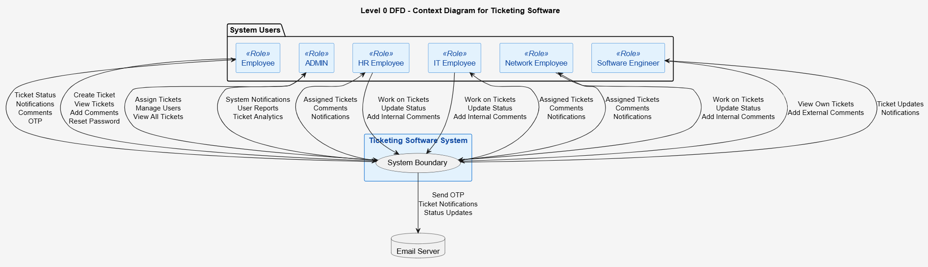
Level 1

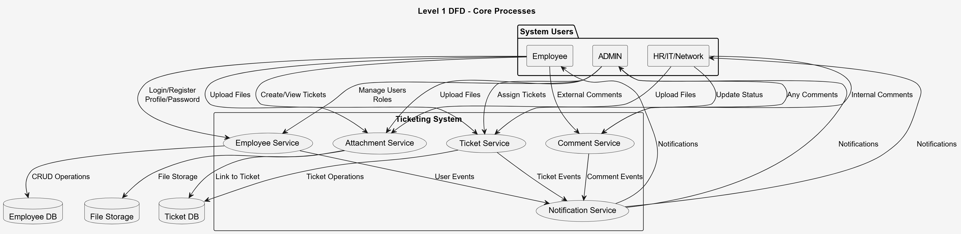

Level 2

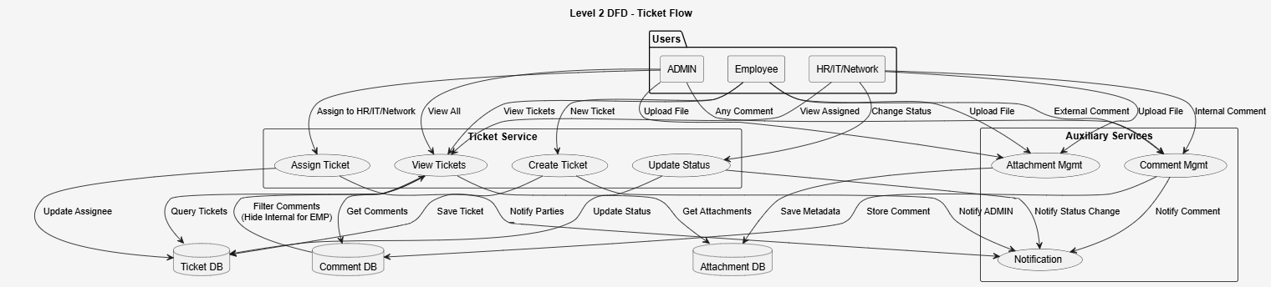

Level 3

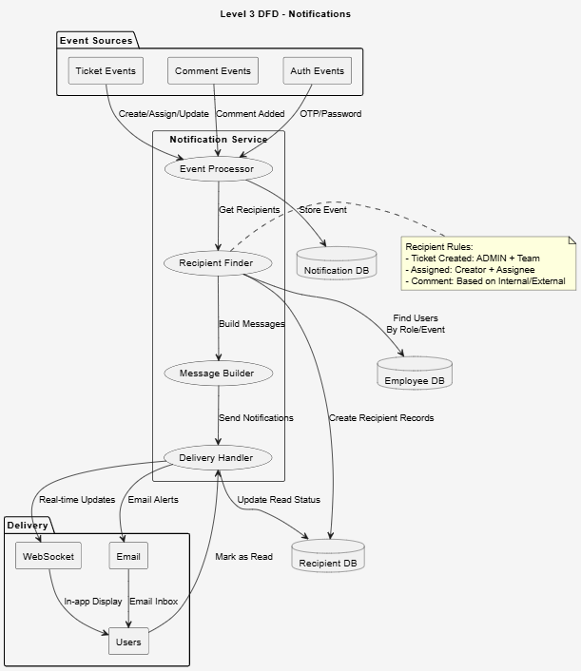

B.UML (Unified Modeling Language) diagrams visually represent system architecture, workflows, and interactions.
Use Case Diagram
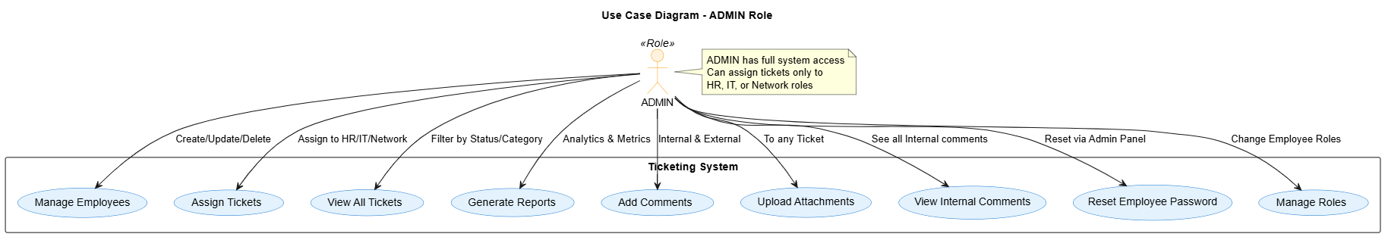
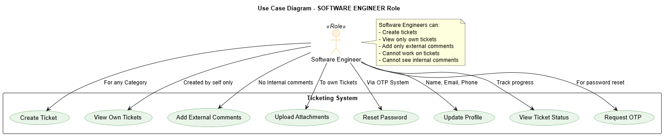
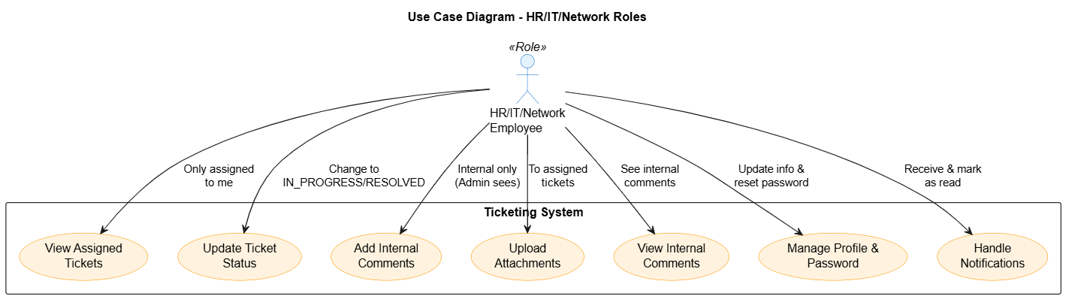

Sequence Diagram
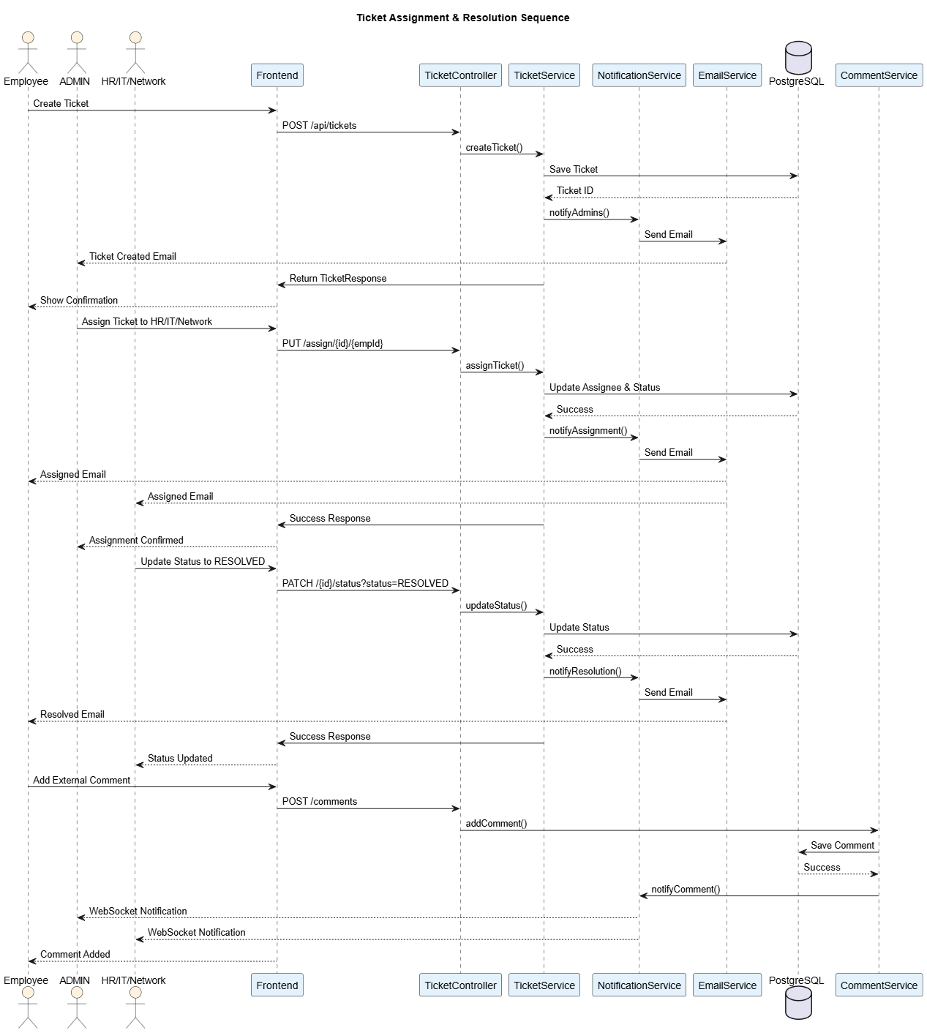

Activity Diagram
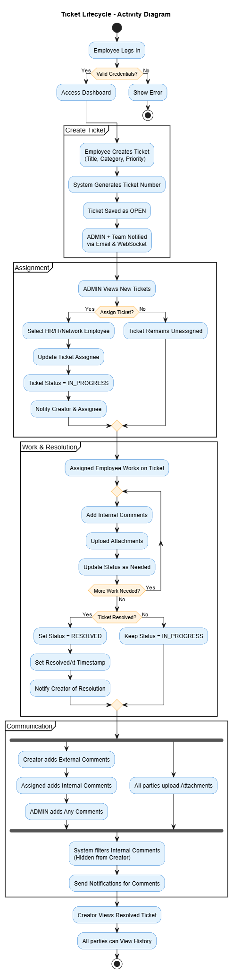
Deployment Diagram
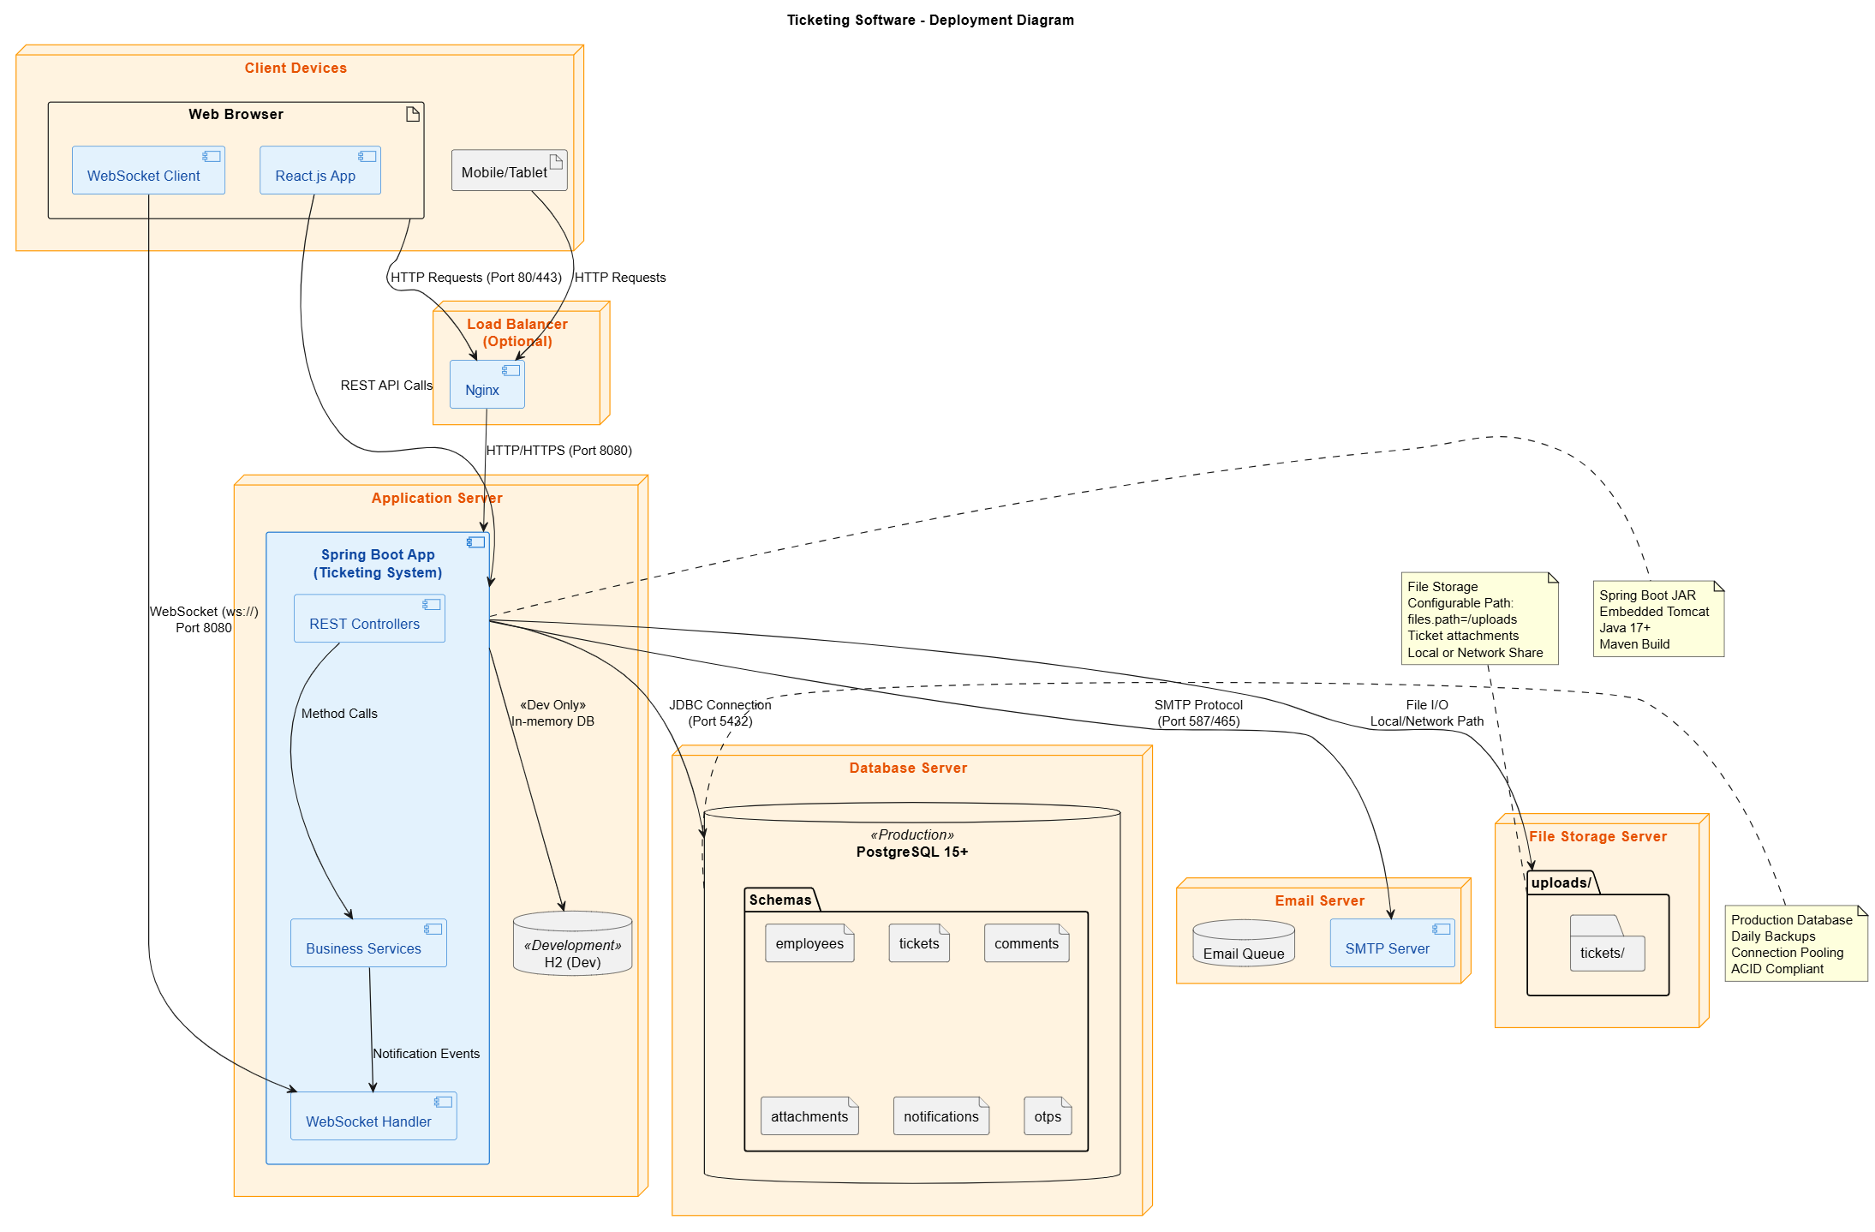
Class Diagram
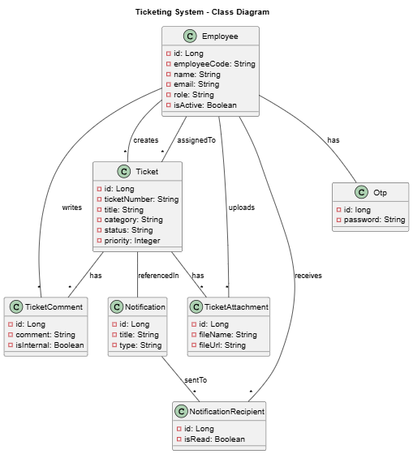

Collaborative Diagram
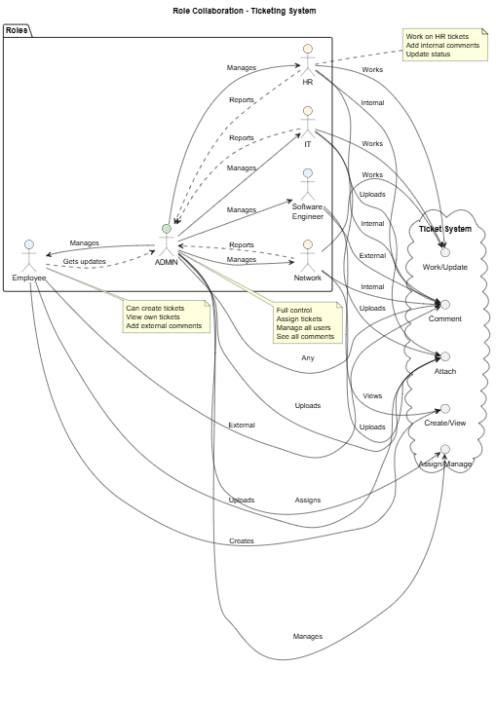

Component Diagram
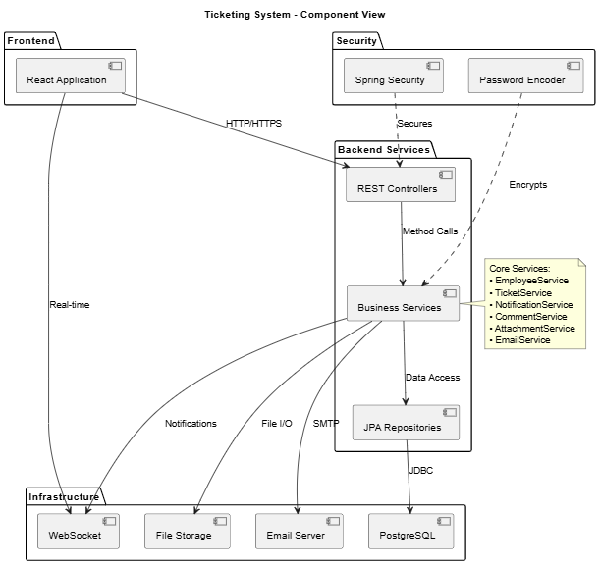

C. Data Dictionaries
Employees
Column Name | Data Type | Nullable | Default Value | Key / Constraint | Description
id | BIGINT | No | — | Primary Key | Unique identifier for an employee
created_at | TIMESTAMP(6) | Yes | — | — | Date and time when the employee record was created
email | VARCHAR(255) | Yes | — | Unique | Employee’s official email address
employee_code | VARCHAR(255) | Yes | — | Unique | System-generated or organization-defined employee code
is_active | BOOLEAN | Yes | — | — | Indicates whether the employee account is active
joining_date | DATE | Yes | — | — | Employee’s official joining date
name | VARCHAR(255) | Yes | — | — | Full name of the employee
password | VARCHAR(255) | Yes | — | — | Encrypted password for authentication
phone | VARCHAR(255) | Yes | — | — | Contact phone number of the employee
role | VARCHAR(255) | Yes | — | CHECK Constraint | Employee role (SOFTWARE_ENGINEER, IT, NETWORK, HR, ADMIN)

Notification Recipients
Column Name | Data Type | Nullable | Default Value | Key / Constraint | Description
id | BIGINT | No | — | Primary Key | Unique identifier for the notification recipient record
is_read | BOOLEAN | Yes | — | — | Indicates whether the notification has been read by the employee
read_at | TIMESTAMP(6) | Yes | — | — | Date and time when the notification was marked as read
employee_id | BIGINT | No | — | Foreign Key → employees(id) | Employee who received the notification
notification_id | BIGINT | No | — | Foreign Key → notifications(id) | Notification assigned to the employee

Notifications
Column Name | Data Type | Nullable | Default Value | Key / Constraint | Description
id | BIGINT | No | — | Primary Key | Unique identifier for the notification
created_at | TIMESTAMP(6) | Yes | — | — | Date and time when the notification was created
title | VARCHAR(255) | Yes | — | — | Short title or subject of the notification
message | VARCHAR(255) | Yes | — | — | Detailed notification message content
type | VARCHAR(255) | Yes | — | CHECK Constraint | Type of notification event
ticket_id | BIGINT | Yes | — | Foreign Key → tickets(id) | Related ticket for which the notification was generated

Otps
Column Name | Data Type | Nullable | Default Value | Key / Constraint | Description
id | BIGINT | No | Auto-generated (IDENTITY) | Primary Key | Unique identifier for the OTP record
created_at | TIMESTAMP(6) | Yes | — | — | Date and time when the OTP was generated
password | VARCHAR(255) | Yes | — | — | One-time password (usually hashed or encrypted)
employee_id | BIGINT | Yes | — | Foreign Key, Unique → employees(id) | Employee associated with the OTP

Ticket Attachments
Column Name | Data Type | Nullable | Default Value | Key / Constraint | Description
id | BIGINT | No | — | Primary Key | Unique identifier for the ticket attachment
file_name | VARCHAR(255) | Yes | — | — | Original name of the uploaded file
file_url | VARCHAR(255) | Yes | — | — | Storage location or access URL of the file
size | BIGINT | Yes | — | — | File size in bytes
uploaded_at | TIMESTAMP(6) | Yes | — | — | Date and time when the file was uploaded
ticket_id | BIGINT | Yes | — | Foreign Key → tickets(id) | Ticket to which the attachment belongs
uploaded_by_id | BIGINT | Yes | — | Foreign Key → employees(id) | Employee who uploaded the attachment

Ticket Comments
Column Name | Data Type | Nullable | Default Value | Key / Constraint | Description
id | BIGINT | No | — | Primary Key | Unique identifier for the ticket comment
comment | VARCHAR(1500) | Yes | — | — | Text content of the comment
commented_at | TIMESTAMP(6) | Yes | — | — | Date and time when the comment was posted
is_internal | BOOLEAN | Yes | — | — | Indicates whether the comment is internal (visible only to staff/admin)
commented_by_id | BIGINT | Yes | — | Foreign Key → employees(id) | Employee who posted the comment
ticket_id | BIGINT | Yes | — | Foreign Key → tickets(id) | Ticket to which the comment belongs

Tickets
Column Name | Data Type | Nullable | Default Value | Key / Constraint | Description
id | BIGINT | No | — | Primary Key | Unique identifier for the ticket
ticket_number | VARCHAR(255) | Yes | — | — | Human-readable unique ticket reference (e.g., TKT-2025-001)
title | VARCHAR(255) | Yes | — | — | Short summary of the issue
description | VARCHAR(2000) | Yes | — | — | Detailed description of the issue
category | VARCHAR(255) | Yes | — | CHECK Constraint | Ticket category (IT, NETWORK, HR, SOFTWARE)
priority | INTEGER | Yes | — | — | Priority level of the ticket (e.g., 1-High, 2-Medium, 3-Low)
status | VARCHAR(255) | Yes | — | CHECK Constraint | Current ticket status
created_at | TIMESTAMP(6) | Yes | — | — | Date and time when the ticket was created
updated_at | TIMESTAMP(6) | Yes | — | — | Date and time when the ticket was last updated
resolved_at | TIMESTAMP(6) | Yes | — | — | Date and time when the ticket was resolved
is_deleted | BOOLEAN | Yes | — | — | Soft-delete flag for logical deletion
created_by | BIGINT | Yes | — | Foreign Key → employees(id) | Employee who created the ticket
assigned_to | BIGINT | Yes | — | Foreign Key → employees(id) | Employee assigned to handle the ticket

8. TECHNOLOGY DESCRIPTION & IMPLEMENTATION
8.1 Technology Stack
- Backend: Java 17+, Spring Boot 3.x, Spring Data JPA, Spring Security, Spring WebSocket
- Frontend: React.js 18+, Tailwind CSS 3.x, Axios, React Router
- Database: PostgreSQL 15+
- Build Tool: Maven
- Development: Spring Tool Suite 4.x, VS Code
- Version Control: Git
- API Testing: Postman
8.2 Implementation Architecture
- Pattern: Layered monolithic architecture
- Backend Structure:
  - Controllers (REST API endpoints)
  - Services (Business logic layer)
  - Repositories (Data access layer)
  - Models (JPA entities)
  - DTOs (Data Transfer Objects)
  - Enums (Role, Status, Category types)
- Design Patterns Used:
  - Dependency Injection (Spring IoC)
  - Repository Pattern (JPA Repositories)
  - DTO Pattern (Request/Response objects)
  - Service Layer Pattern (Business logic encapsulation)
  - Observer Pattern (Notification system)
8.3 Security Implementation
- Authentication: Spring Security with session management
- Password Security: BCrypt hashing with PasswordEncoder
- Authorization: Role-Based Access Control (RBAC) using @PreAuthorize
- OTP Security: Time-limited encrypted OTPs for password reset
- API Protection: Input validation, SQL injection prevention, CORS configuration
8.4 Database Implementation
- Schema Design: Normalized tables with foreign key relationships
- Key Entities: Employees, Tickets, Comments, Attachments, Notifications, OTPs
- Indexing: Primary keys, unique constraints, performance indexes on status/category fields
- Transactions: Spring @Transactional with ACID compliance
- Connection Management: HikariCP connection pooling
8.5 Real-Time Features
- Technology: Spring WebSocket with STOMP protocol
- Configuration: Simple message broker with /queue destinations
- Notification Delivery: User-specific queues (/queue/notifications/{userId})
- Event Types: Ticket creation, assignment, status changes, comments
- Client Integration: WebSocket connections from React frontend
8.6 File Handling
- Storage: Configurable local filesystem path (files.path property)
- Organization: Directory structure: uploads/tickets/{ticketId}/
- Naming: UUID-based file names to prevent collisions
- Metadata: File details stored in database (name, size, uploader, timestamp)
- Security: Access control based on ticket permissions
8.7 Email Integration
- Protocol: SMTP via JavaMailSender
- Configuration: Externalized in application.properties
- Email Types: OTP messages, ticket notifications, status updates
- Asynchronous Processing: Non-blocking email sending
- Templates: Parameterized messages with dynamic content
8.8 Exception Handling
- Custom Exceptions: ResourceNotFoundException, ResourceAlreadyExistsException
- Global Handler: @ControllerAdvice with ResponseEntity error responses
- HTTP Status Mapping: Proper status codes (404, 409, 400, 500)
- Error Format: Structured JSON responses with message and timestamp
- Logging: Detailed error logging for debugging
8.9 Testing Strategy
- Unit Testing: JUnit 5 with Mockito for service layer
- Integration Testing: Spring Boot Test with Testcontainers
- API Testing: RestAssured for endpoint validation
- Frontend Testing: Jest and React Testing Library
- Test Coverage: Critical paths including authentication and ticket workflow
8.10 Build and Deployment
- Packaging: Executable JAR with embedded Tomcat
- Configuration: Environment-specific property files (dev/prod)
- Deployment Options:
  - Traditional server deployment
  - Docker containerization
  - Cloud platforms (AWS, Azure, GCP)
- Frontend Serving: Static files via Spring Boot or separate web server

9. CODING
EmployeeController.java
package com.ts.controllers;

import java.util.HashMap;
import java.util.List;
import java.util.Map;

import org.springframework.http.HttpStatus;
import org.springframework.http.ResponseEntity;
import org.springframework.web.bind.annotation.DeleteMapping;
import org.springframework.web.bind.annotation.GetMapping;
import org.springframework.web.bind.annotation.PathVariable;
import org.springframework.web.bind.annotation.PostMapping;
import org.springframework.web.bind.annotation.PutMapping;
import org.springframework.web.bind.annotation.RequestBody;
import org.springframework.web.bind.annotation.RequestMapping;
import org.springframework.web.bind.annotation.RestController;

import com.ts.dtos.EmployeeCreateRequest;
import com.ts.dtos.EmployeeResponse;
import com.ts.enums.Role;
import com.ts.services.EmployeeService;

import lombok.RequiredArgsConstructor;

@RestController
@RequestMapping("/api/employees")
@RequiredArgsConstructor
public class EmployeeController {

private final EmployeeService employeeService;

@GetMapping("/roles")
public Role[] fetchRoles() {
return Role.values();
}

@PostMapping
public EmployeeResponse createEmployee(
@RequestBody EmployeeCreateRequest request
) {
return employeeService.createEmployee(request);
}

@GetMapping
public List<EmployeeResponse> getAllEmployees() {
return employeeService.getAll();
}

@GetMapping("/role/{role}")
public List<EmployeeResponse> getAllEmployees(@PathVariable Role role) {
return employeeService.getEmployeesByRole(role);
}

@GetMapping("/{id}")
public EmployeeResponse getEmployeeById(@PathVariable Long id) {
return employeeService.findById(id);
}

@PutMapping("/{id}")
public EmployeeResponse updateEmployee( @PathVariable Long id,
@RequestBody EmployeeCreateRequest request
) {
return employeeService.updateEmployee(id,request);
}

@DeleteMapping("/{id}")
public ResponseEntity<?> deleteEmployeeById(@PathVariable Long id) {
employeeService.deleteById(id);
return ResponseEntity.ok("Employee removed successfully");
}

@PostMapping("/otp/send")
public ResponseEntity<Map<String, String>> sendOtp(@RequestBody Map<String, String> jsonObject) {

String email = jsonObject.get("email");
boolean isGenerated = employeeService.generateOtp(email);

Map<String, String> response = new HashMap<>();

if (isGenerated) {
response.put("message", "OTP Generated Successfully");
return ResponseEntity.ok(response);
} else {
response.put("error", "Failed to generate OTP");
return ResponseEntity.status(HttpStatus.BAD_REQUEST).body(response);
}
}

@PostMapping("/otp/verify")
public ResponseEntity<Map<String, String>> verifyOtp(@RequestBody Map<String, String> jsonObject) {

String email = jsonObject.get("email");
String otp = jsonObject.get("otp");

boolean isVerified = employeeService.verifyOtp(email, otp);
Map<String, String> response = new HashMap<>();

if (isVerified) {
response.put("message", "OTP verified successfully");
return ResponseEntity.ok(response);
} else {
response.put("message", "Invalid OTP");
return ResponseEntity.status(HttpStatus.BAD_REQUEST).body(response);
}
}

@PostMapping("/password/reset")
public ResponseEntity<Map<String, String>> resetPassword(@RequestBody Map<String, String> jsonObject) {

String email = jsonObject.get("email");
String password = jsonObject.get("password");

boolean isReset = employeeService.resetPassword(email, password);
Map<String, String> response = new HashMap<>();

if (isReset) {
response.put("message", "Password reset successfully");
return ResponseEntity.ok(response);
} else {
response.put("message", "Password didn't reset");
return ResponseEntity.status(HttpStatus.BAD_REQUEST).body(response);
}
}

}
NotificationController.java
package com.ts.controllers;

import java.util.List;

import org.springframework.security.core.Authentication;
import org.springframework.web.bind.annotation.GetMapping;
import org.springframework.web.bind.annotation.PatchMapping;
import org.springframework.web.bind.annotation.PathVariable;
import org.springframework.web.bind.annotation.PostMapping;
import org.springframework.web.bind.annotation.PutMapping;
import org.springframework.web.bind.annotation.RequestBody;
import org.springframework.web.bind.annotation.RequestMapping;
import org.springframework.web.bind.annotation.RequestParam;
import org.springframework.web.bind.annotation.RestController;

import com.ts.dtos.TicketCreateRequest;
import com.ts.dtos.TicketDetailResponse;
import com.ts.dtos.TicketResponse;
import com.ts.enums.TicketStatus;
import com.ts.models.Employee;
import com.ts.services.TicketService;

import lombok.RequiredArgsConstructor;

@RestController
@RequestMapping("/api/tickets")
@RequiredArgsConstructor
public class TicketController {

private final TicketService ticketService;

@GetMapping("/statuses")
public TicketStatus[] getAllStatuses() {
return TicketStatus.values();
}

@PostMapping
public TicketResponse createTicket(@RequestBody TicketCreateRequest request, Authentication auth) {
Employee user = (Employee) auth.getPrincipal();
return ticketService.createTicket(request, user);
}

@GetMapping("/{id}")
public TicketDetailResponse getTicket(@PathVariable Long id, Authentication auth) {
Employee user = (Employee) auth.getPrincipal();
return ticketService.getTicketDetail(id, user);
}

@GetMapping
public List<TicketDetailResponse> getTickets(Authentication auth) {
Employee user = (Employee) auth.getPrincipal();
var tickets = ticketService.getAllTicketDetails(user);
tickets.forEach(System.out::println);
return tickets;
}

@GetMapping("/live")
public List<TicketResponse> getLiveTickets(Authentication auth) {
Employee user = (Employee) auth.getPrincipal();
return ticketService.fetchLiveTickets(user);
}

@GetMapping("/resolved")
public List<TicketResponse> getResolvedTickets(Authentication auth) {
Employee user = (Employee) auth.getPrincipal();
return ticketService.fetchResolvedTickets(user);
}

@GetMapping("/open")
public List<TicketResponse> getOpenTickets(Authentication auth) {
Employee user = (Employee) auth.getPrincipal();
return ticketService.fetchOpenTickets(user);
}

@PatchMapping("/{id}/status")
public void updateStatus(@PathVariable Long id, @RequestParam TicketStatus status, Authentication auth) {
ticketService.updateStatus(id, status, (Employee) auth.getPrincipal());
}

@PutMapping("/{id}/assign/{employeeId}")
public void assignTicket(@PathVariable Long id, @PathVariable Long employeeId, Authentication auth) {
ticketService.assignTicket(id, employeeId, (Employee) auth.getPrincipal());
}
}

EmployeeDashboard.jsx

import { useState, useEffect } from 'react';
import { useNavigate } from 'react-router-dom';
import {
BarChart3,
Calendar,
Clock,
TrendingUp,
CheckCircle,
XCircle,
AlertCircle,
Ticket,
Users,
MessageSquare,
FileText,
ChevronRight,
Bell,
Star,
Award,
Zap,
PieChart,
Activity,
UserCheck,
FolderOpen,
Shield,
Briefcase,
Target
} from 'lucide-react';
import EmployeeHeader from '../../Components/EmployeeHeader';
import { API_BASE_URL } from '../../config';

const EmployeeDashboard = () => {
const navigate = useNavigate();
const [employeeData, setEmployeeData] = useState(null);
const [greeting, setGreeting] = useState('');
const [stats, setStats] = useState({
totalTickets: 0,
openTickets: 0,
inProgressTickets: 0,
resolvedTickets: 0,
assignedTickets: 0,
myTickets: 0
});
const [recentTickets, setRecentTickets] = useState([]);
const [loading, setLoading] = useState(true);
const [todaysDate, setTodaysDate] = useState('');
const [isAdmin, setIsAdmin] = useState(false);

// Get auth token
const getAuthToken = () => {
return localStorage.getItem('authToken');
};

// Fetch employee data
useEffect(() => {
const storedData = localStorage.getItem('employeeData');
if (storedData) {
try {
const data = JSON.parse(storedData);
setEmployeeData(data);
setIsAdmin(data.role === 'ADMIN');
} catch (error) {
console.error('Error parsing employee data:', error);
}
}
}, []);

// Set greeting based on time
useEffect(() => {
const updateGreeting = () => {
const hour = new Date().getHours();
let timeGreeting = '';

if (hour < 12) {
timeGreeting = 'Good Morning';
} else if (hour < 17) {
timeGreeting = 'Good Afternoon';
} else if (hour < 21) {
timeGreeting = 'Good Evening';
} else {
timeGreeting = 'Good Night';
}

setGreeting(timeGreeting);
};

updateGreeting();
const interval = setInterval(updateGreeting, 60000);
return () => clearInterval(interval);
}, []);

// Set today's date
useEffect(() => {
const updateDate = () => {
const today = new Date();
const options = {
weekday: 'long',
year: 'numeric',
month: 'long',
day: 'numeric'
};
setTodaysDate(today.toLocaleDateString('en-US', options));
};

updateDate();
const interval = setInterval(updateDate, 60000);
return () => clearInterval(interval);
}, []);

// Get base path for navigation
const getBasePath = () => {
if (!employeeData?.role) return '';
return `/${employeeData.role.toLowerCase().replace('_', '-')}`;
};

// Fetch dashboard data
const fetchDashboardData = async () => {
setLoading(true);
try {
const token = getAuthToken();
if (!token) {
navigate('/employees/login');
return;
}

// Fetch all tickets
const ticketsResponse = await fetch(`${API_BASE_URL}/tickets`, {
method: 'GET',
headers: {
'Authorization': `Bearer ${token}`,
'Content-Type': 'application/json',
},
});

if (ticketsResponse.ok) {
const allTickets = await ticketsResponse.json();

// Filter tickets based on user role
let filteredTickets = allTickets;

if (!isAdmin) {
// For non-admin users, show only tickets where they are creator or assignee
filteredTickets = allTickets.filter(ticket =>
ticket.ticket.createdBy?.id === employeeData.id ||
ticket.ticket.assignedTo?.id === employeeData.id
);
}

// Calculate stats
const totalTickets = filteredTickets.length;
const openTickets = filteredTickets.filter(t => t.ticket.status === 'OPEN').length;
const inProgressTickets = filteredTickets.filter(t => t.ticket.status === 'IN_PROGRESS').length;
const resolvedTickets = filteredTickets.filter(t =>
t.ticket.status === 'RESOLVED' || t.ticket.status === 'CLOSED'
).length;
const assignedTickets = filteredTickets.filter(t =>
t.ticket.assignedTo?.id === employeeData.id && t.ticket.status !== 'CLOSED'
).length;
const myTickets = filteredTickets.filter(t =>
t.ticket.createdBy?.id === employeeData.id
).length;

setStats({
totalTickets,
openTickets,
inProgressTickets,
resolvedTickets,
assignedTickets,
myTickets
});

// Get recent tickets (last 5)
const recent = filteredTickets
.sort((a, b) => new Date(b.ticket.createdAt) - new Date(a.ticket.createdAt))
.slice(0, 5)
.map(ticket => ({
id: ticket.ticket.id,
number: ticket.ticket.ticketNumber,
title: ticket.ticket.title,
// priority: getPriorityLabel(ticket.ticket.priority),
priority: ticket.ticket.priority,
status: ticket.ticket.status,
category: ticket.ticket.category,
createdAt: formatTimeAgo(ticket.ticket.createdAt),
isAssignedToMe: ticket.ticket.assignedTo?.id === employeeData.id,
isCreatedByMe: ticket.ticket.createdBy?.id === employeeData.id
}));

setRecentTickets(recent);
} else if (ticketsResponse.status === 401) {
localStorage.removeItem('authToken');
localStorage.removeItem('employeeData');
navigate('/employees/login');
return;
}

setLoading(false);
} catch (error) {
console.error('Error fetching dashboard data:', error);
setLoading(false);
}
};

useEffect(() => {
if (employeeData) {
fetchDashboardData();
}
}, [employeeData]);

// Format time ago
const formatTimeAgo = (dateString) => {
if (!dateString) return '';
const date = new Date(dateString);
const now = new Date();
const diffInMs = now - date;
const diffInHours = Math.floor(diffInMs / (1000 * 60 * 60));
const diffInDays = Math.floor(diffInHours / 24);

if (diffInHours < 1) {
const diffInMinutes = Math.floor(diffInMs / (1000 * 60));
return `${diffInMinutes}m ago`;
} else if (diffInHours < 24) {
return `${diffInHours}h ago`;
} else {
return `${diffInDays}d ago`;
}
};

// Get priority label
// const getPriorityLabel = (priority) => {
// switch (priority) {
// case 1: return 'CRITICAL';
// case 2: return 'HIGH';
// case 3: return 'MEDIUM';
// case 4: return 'LOW';
// default: return 'MEDIUM';
// }
// };

// Get priority color
const getPriorityColor = (priority) => {
switch (priority) {
case 'CRITICAL': return 'bg-red-100 text-red-800';
case 'HIGH': return 'bg-orange-100 text-orange-800';
case 'MEDIUM': return 'bg-yellow-100 text-yellow-800';
case 'LOW': return 'bg-green-100 text-green-800';
default: return 'bg-gray-100 text-gray-800';
}
};

// Get status color
const getStatusColor = (status) => {
switch (status) {
case 'OPEN': return 'bg-blue-100 text-blue-800';
case 'IN_PROGRESS': return 'bg-purple-100 text-purple-800';
case 'WAITING_FOR_INFO': return 'bg-yellow-100 text-yellow-800';
case 'RESOLVED': return 'bg-green-100 text-green-800';
case 'CLOSED': return 'bg-gray-100 text-gray-800';
default: return 'bg-gray-100 text-gray-800';
}
};

// Quick actions based on role
const getQuickActions = () => {
const basePath = getBasePath();
const actions = [
{
label: 'View Tickets',
icon: <FileText className="w-5 h-5" />,
action: () => navigate(`${basePath}/tickets`)
},
];

if (isAdmin) {
actions.unshift(
{
label: 'Create Ticket',
icon: <Ticket className="w-5 h-5" />,
action: () => navigate(`${basePath}/tickets/raise`)
},
{
label: 'Manage Employees',
icon: <Users className="w-5 h-5" />,
action: () => navigate(`${basePath}/employees`)
}
);
} else {
actions.unshift(
{
label: 'Create Ticket',
icon: <Ticket className="w-5 h-5" />,
action: () => navigate(`${basePath}/tickets/raise`)
}
);
}

return actions;
};

// Refresh dashboard
const handleRefresh = () => {
fetchDashboardData();
};

return (
<div className="min-h-screen bg-gray-50">
<EmployeeHeader />

<main className="max-w-7xl mx-auto px-4 sm:px-6 lg:px-8 py-8">
{/* Welcome Section */}
<div className="mb-8">
<div className="flex flex-col md:flex-row md:items-center md:justify-between">
<div>
<div className="flex items-center gap-3">
<h1 className="text-3xl md:text-4xl font-bold text-gray-900">
{greeting}, {employeeData?.name?.split(' ')[0] || 'Employee'}!
</h1>
{isAdmin && (
<span className="px-3 py-1 bg-purple-100 text-purple-800 text-sm font-medium rounded-full flex items-center gap-1">
<Shield className="w-4 h-4" />
Admin
</span>
)}
</div>
<p className="text-gray-600 mt-2">
{todaysDate}
</p>
<div className="mt-2 flex items-center text-sm text-gray-500">
<Clock className="w-4 h-4 mr-1" />
<span>{new Date().toLocaleTimeString('en-US', {
hour: '2-digit',
minute: '2-digit',
hour12: true
})}</span>
</div>
</div>
<div className="mt-4 md:mt-0 flex gap-3">
<button
onClick={handleRefresh}
className="flex items-center space-x-2 px-4 py-2 border border-gray-300 text-gray-700 font-medium rounded-lg hover:bg-gray-50 transition-colors cursor-pointer"
>
<svg className="w-4 h-4" fill="none" stroke="currentColor" viewBox="0 0 24 24">
<path strokeLinecap="round" strokeLinejoin="round" strokeWidth={2} d="M4 4v5h.582m15.356 2A8.001 8.001 0 004.582 9m0 0H9m11 11v-5h-.581m0 0a8.003 8.003 0 01-15.357-2m15.357 2H15" />
</svg>
<span>Refresh</span>
</button>
<div className="flex items-center space-x-2 bg-gradient-to-r from-blue-50 to-blue-100 border border-blue-200 rounded-xl px-4 py-3">
<Briefcase className="w-5 h-5 text-blue-600" />
<div>
<div className="text-sm font-medium text-blue-900">
{employeeData?.role?.replace('_', ' ') || 'Employee'}
</div>
<div className="text-xs text-blue-700">{employeeData?.email}</div>
</div>
</div>
</div>
</div>
</div>

{/* Stats Grid */}
<div className="grid grid-cols-1 md:grid-cols-2 lg:grid-cols-3 gap-6 mb-8">
{/* Total Tickets */}
<div className="bg-white rounded-xl border border-gray-200 p-6 shadow-sm hover:shadow-md transition-shadow">
<div className="flex items-center justify-between">
<div>
<p className="text-sm text-gray-600">Total Tickets</p>
<p className="text-2xl font-bold text-gray-900 mt-1">{stats.totalTickets}</p>
</div>
<div className="p-3 bg-blue-100 rounded-lg">
<Ticket className="w-6 h-6 text-blue-600" />
</div>
</div>
<div className="mt-4">
<div className="flex items-center justify-between text-sm text-gray-600">
<span>Open: {stats.openTickets}</span>
<span>In Progress: {stats.inProgressTickets}</span>
<span>Resolved: {stats.resolvedTickets}</span>
</div>
</div>
</div>

{/* My Tickets */}
<div className="bg-white rounded-xl border border-gray-200 p-6 shadow-sm hover:shadow-md transition-shadow">
<div className="flex items-center justify-between">
<div>
<p className="text-sm text-gray-600">My Tickets</p>
<p className="text-2xl font-bold text-gray-900 mt-1">{stats.myTickets}</p>
</div>
<div className="p-3 bg-green-100 rounded-lg">
<FileText className="w-6 h-6 text-green-600" />
</div>
</div>
<div className="mt-4 flex items-center text-sm text-green-600 font-medium">
<UserCheck className="w-4 h-4 mr-1" />
<span>Created by me</span>
</div>
</div>

{/* Assigned to Me */}
<div className="bg-white rounded-xl border border-gray-200 p-6 shadow-sm hover:shadow-md transition-shadow">
<div className="flex items-center justify-between">
<div>
<p className="text-sm text-gray-600">Assigned to Me</p>
<p className="text-2xl font-bold text-gray-900 mt-1">{stats.assignedTickets}</p>
</div>
<div className="p-3 bg-orange-100 rounded-lg">
<Target className="w-6 h-6 text-orange-600" />
</div>
</div>
<div className="mt-4">
<div className="h-2 bg-gray-200 rounded-full overflow-hidden">
<div
className="h-full bg-orange-500 rounded-full"
style={{ width: `${stats.totalTickets > 0 ? (stats.assignedTickets / stats.totalTickets) * 100 : 0}%` }}
></div>
</div>
<p className="text-xs text-gray-500 mt-2">
{stats.assignedTickets} ticket(s) assigned to you
</p>
</div>
</div>
</div>

{/* Main Content Grid */}
<div className="grid grid-cols-1 lg:grid-cols-3 gap-8">
{/* Left Column - Recent Tickets */}
<div className="lg:col-span-2 space-y-8">
{/* Recent Tickets */}
<div className="bg-white rounded-xl border border-gray-200 shadow-sm overflow-hidden">
<div className="px-6 py-4 border-b border-gray-200">
<div className="flex items-center justify-between">
<h2 className="text-lg font-semibold text-gray-900">Recent Tickets</h2>
<button
onClick={() => navigate(`${getBasePath()}/tickets`)}
className="text-sm text-blue-600 hover:text-blue-800 font-medium flex items-center space-x-1 cursor-pointer"
>
<span>View All</span>
<ChevronRight className="w-4 h-4" />
</button>
</div>
</div>
<div className="divide-y divide-gray-200">
{loading ? (
<div className="px-6 py-8 text-center">
<div className="animate-spin rounded-full h-8 w-8 border-b-2 border-blue-600 mx-auto"></div>
<p className="mt-2 text-gray-600">Loading tickets...</p>
</div>
) : recentTickets.length === 0 ? (
<div className="px-6 py-8 text-center">
<Ticket className="w-12 h-12 text-gray-400 mx-auto mb-4" />
<h3 className="text-lg font-medium text-gray-900 mb-2">No tickets found</h3>
<p className="text-gray-600 mb-4">
{isAdmin ? 'No tickets in the system yet' : 'You have no tickets yet'}
</p>
<button
onClick={() => navigate(`${getBasePath()}/tickets/raise`)}
className="px-4 py-2 bg-blue-600 text-white font-medium rounded-lg hover:bg-blue-700 transition-colors cursor-pointer"
>
Create Ticket
</button>
</div>
) : (
recentTickets.map((ticket) => (
<div
key={ticket.id}
className="px-6 py-4 hover:bg-gray-50 transition-colors cursor-pointer"
onClick={() => navigate(`${getBasePath()}/tickets/${ticket.id}`)}
>
<div className="flex items-center justify-between">
<div className="flex-1">
<div className="flex items-center space-x-3">
<span className="text-sm font-medium text-gray-900">{ticket.number}</span>
<span className={`px-2 py-1 rounded-full text-xs font-medium ${getPriorityColor(ticket.priority)}`}>
{ticket.priority}
</span>
{ticket.isAssignedToMe && (
<span className="px-2 py-1 rounded-full text-xs font-medium bg-blue-100 text-blue-800">
Assigned
</span>
)}
{ticket.isCreatedByMe && !ticket.isAssignedToMe && (
<span className="px-2 py-1 rounded-full text-xs font-medium bg-green-100 text-green-800">
Created
</span>
)}
</div>
<h3 className="text-sm text-gray-900 font-medium mt-1">{ticket.title}</h3>
<div className="flex items-center space-x-4 mt-2">
<span className={`px-2 py-1 rounded-full text-xs font-medium ${getStatusColor(ticket.status)}`}>
{ticket.status.replace(/_/g, ' ')}
</span>
<span className="text-xs text-gray-500">{ticket.category}</span>
<span className="text-xs text-gray-500">{ticket.createdAt}</span>
</div>
</div>
<ChevronRight className="w-5 h-5 text-gray-400" />
</div>
</div>
))
)}
</div>
</div>

{/* Admin Overview (Only for Admin) */}
{isAdmin && (
<div className="bg-white rounded-xl border border-gray-200 shadow-sm p-6">
<div className="flex items-center justify-between mb-6">
<h2 className="text-lg font-semibold text-gray-900">System Overview</h2>
<div className="flex items-center space-x-2">
<Users className="w-5 h-5 text-gray-400" />
</div>
</div>
<div className="grid grid-cols-2 gap-4">
<div className="bg-gray-50 rounded-lg p-4">
<div className="text-sm text-gray-600">Ticket Distribution</div>
<div className="mt-2 space-y-2">
<div className="flex justify-between text-sm">
<span>Open</span>
<span className="font-medium">{stats.openTickets}</span>
</div>
<div className="flex justify-between text-sm">
<span>In Progress</span>
<span className="font-medium">{stats.inProgressTickets}</span>
</div>
<div className="flex justify-between text-sm">
<span>Resolved/Closed</span>
<span className="font-medium">{stats.resolvedTickets}</span>
</div>
</div>
</div>
<div className="bg-gray-50 rounded-lg p-4">
<div className="text-sm text-gray-600">Quick Stats</div>
<div className="mt-2 space-y-2">
<div className="flex justify-between text-sm">
<span>Total Users</span>
<span className="font-medium">{stats.totalTickets > 0 ? 'Multiple' : 'None'}</span>
</div>
<div className="flex justify-between text-sm">
<span>Categories</span>
<span className="font-medium">4</span>
</div>
<div className="flex justify-between text-sm">
<span>Avg. Resolution</span>
<span className="font-medium">-</span>
</div>
</div>
</div>
</div>
</div>
)}
</div>

{/* Right Column - Quick Actions */}
<div className="space-y-8">
{/* Quick Actions */}
<div className="bg-white rounded-xl border border-gray-200 shadow-sm overflow-hidden">
<div className="px-6 py-4 border-b border-gray-200">
<h2 className="text-lg font-semibold text-gray-900">Quick Actions</h2>
</div>
<div className="p-4 space-y-2">
{getQuickActions().map((action, index) => (
<button
key={index}
onClick={action.action}
className="w-full flex items-center space-x-3 px-4 py-3 rounded-lg text-left hover:bg-gray-50 transition-colors cursor-pointer group border border-gray-100 hover:border-gray-200"
>
<div className="p-2 bg-blue-100 text-blue-600 rounded-lg group-hover:bg-blue-200 transition-colors">
{action.icon}
</div>
<span className="text-sm font-medium text-gray-900 flex-1">{action.label}</span>
<ChevronRight className="w-4 h-4 text-gray-400" />
</button>
))}
</div>
</div>

{/* Status Summary */}
<div className="bg-white rounded-xl border border-gray-200 shadow-sm overflow-hidden">
<div className="px-6 py-4 border-b border-gray-200">
<div className="flex items-center justify-between">
<h2 className="text-lg font-semibold text-gray-900">Ticket Status</h2>
<PieChart className="w-5 h-5 text-gray-400" />
</div>
</div>
<div className="p-6">
<div className="space-y-4">
{[
{ status: 'OPEN', count: stats.openTickets, color: 'bg-blue-500' },
{ status: 'IN_PROGRESS', count: stats.inProgressTickets, color: 'bg-purple-500' },
{ status: 'RESOLVED/CLOSED', count: stats.resolvedTickets, color: 'bg-green-500' },
{ status: 'WAITING_FOR_INFO', count: 0, color: 'bg-yellow-500' },
].map((item) => (
<div key={item.status} className="flex items-center justify-between">
<div className="flex items-center space-x-3">
<div className={`w-3 h-3 ${item.color} rounded-full`}></div>
<span className="text-sm text-gray-700">{item.status.replace(/_/g, ' ')}</span>
</div>
<span className="text-sm font-medium text-gray-900">{item.count}</span>
</div>
))}
</div>
<div className="mt-6 pt-6 border-t border-gray-200">
<div className="flex items-center justify-between text-sm">
<span className="text-gray-600">Total Tickets</span>
<span className="font-medium text-gray-900">{stats.totalTickets}</span>
</div>
</div>
</div>
</div>

{/* Employee Info */}
<div className="bg-white rounded-xl border border-gray-200 shadow-sm overflow-hidden">
<div className="px-6 py-4 border-b border-gray-200">
<div className="flex items-center justify-between">
<h2 className="text-lg font-semibold text-gray-900">Your Information</h2>
<Award className="w-5 h-5 text-gray-400" />
</div>
</div>
<div className="p-6">
<div className="flex items-center space-x-3 mb-4">
<div className="w-12 h-12 bg-blue-100 rounded-full flex items-center justify-center">
<span className="text-blue-600 font-semibold text-lg">
{employeeData?.name?.charAt(0) || 'E'}
</span>
</div>
<div>
<div className="font-medium text-gray-900">{employeeData?.name || 'Employee'}</div>
<div className="text-sm text-gray-600">{employeeData?.email || 'email@example.com'}</div>
</div>
</div>
<div className="space-y-3">
<div className="flex items-center justify-between text-sm">
<span className="text-gray-600">Role</span>
<span className="font-medium text-gray-900">{employeeData?.role?.replace('_', ' ') || 'Employee'}</span>
</div>
<div className="flex items-center justify-between text-sm">
<span className="text-gray-600">Tickets Created</span>
<span className="font-medium text-gray-900">{stats.myTickets}</span>
</div>
<div className="flex items-center justify-between text-sm">
<span className="text-gray-600">Assigned Tickets</span>
<span className="font-medium text-gray-900">{stats.assignedTickets}</span>
</div>
</div>
</div>
</div>
</div>
</div>
</main>
</div>
);
};

export default EmployeeDashboard;

10. TESTING & TEST CASES

Testing ensures the reliability, accuracy, and functionality of the application. Manual testing was conducted across all major modules to validate form inputs, business logic, role-based access, Functional and UI testing was performed to ensure a smooth user experience.

Types of Testing Performed
Functional Testing was carried out to ensure each module of the application performed its intended operations correctly. Features were thoroughly validated for proper output and behavior.
Integration Testing was conducted to verify seamless communication between different layers of the application — such as the controller, service, and repository layers. For example, when a request was submitted, it was ensured that the data properly reached the database and reflected in the admin panel.
User Interface (UI) Testing was done to confirm that pages render correctly, buttons function as expected, and forms respond appropriately to user inputs. The layout and structure were checked using different screen sizes to ensure a responsive design.
Data Validation checks were performed on user-submitted forms and database records to ensure that correct data was saved and displayed. Special attention was paid to date fields, dropdown selections.
Test Cases
Test Case ID | Test Scenario | Input / Preconditions | Expected Result | Status
TC-001 | Create ticket with valid details | Title: Network IssueCategory: NETWORKPriority: HIGHDescription: Internet not working | Ticket is created successfully with a generated ticket number and status set to OPEN | Passed
TC-002 | Assign ticket to HR employee | Ticket ID: 123Employee ID: 456 (Role: HR) | Ticket status changes to IN_PROGRESS and notifications are sent to ticket creator and assignee | Passed
TC-003 | Resolve ticket by HR employee | Ticket ID: 123Status: RESOLVED | Ticket status updated to RESOLVED, resolvedAt timestamp is set, creator is notified | Passed
TC-004 | Add external comment to ticket | Ticket ID: 123Comment: Any updates? | Comment saved as external and notifications sent to ADMIN and assignee | Passed
TC-005 | Add internal comment to ticket | Ticket ID: 123Comment: Investigating issueisInternal: true | Comment saved as internal and visible only to ADMIN | Passed
TC-006 | Upload attachment to own ticket | Ticket ID: 123File: screenshot.png | File uploaded successfully and attachment metadata saved in database | Passed
TC-007 | Request password reset OTP | Email: employee@company.com | OTP is generated, stored in database, and sent to employee email | Passed
TC-008 | Verify valid OTP | Email: employee@company.comOTP: 123456 | OTP verified successfully and user allowed to reset password | Passed
TC-009 | Reset password using verified OTP | Email: employee@company.comNew Password: NewPass123 | Password updated successfully and OTP record removed | Passed
TC-010 | View all tickets as ADMIN | Authenticated ADMIN user | All tickets are displayed regardless of status or assignment | Passed
TC-011 | View assigned tickets as HR employee | Authenticated HR user | Only tickets assigned to the logged-in HR employee are displayed | Passed
TC-012 | View created tickets as Software Engineer | Authenticated Software Engineer user | Only tickets created by the logged-in employee are displayed | Passed
TC-013 | Create new employee with unique email | Name, Email, Role, Password | Employee is created successfully with generated employee code | Passed
TC-014 | Create ticket with invalid input | Title: emptyCategory: null | Validation error returned with appropriate error message | Passed
TC-015 | Real-time notification on ticket assignment | ADMIN assigns ticket to IT employee | IT employee receives instant notification via WebSocket | Passed

11. INPUT & OUTPUT DESIGNS
11.1 Input Design
11.1.1 Employee Registration Form
Purpose: Capture employee details for system onboarding
Input Fields:
- Full Name (Text field, required, max 100 characters)
- Email Address (Email field, required, unique validation)
- Employee Code (Text field, optional, auto-generated if empty)
- Phone Number (Text field, required, 10-digit validation)
- Password (Password field, required, min 8 characters with complexity)
- Confirm Password (Password field, required, must match)
- Role (Dropdown: ADMIN, HR, IT, NETWORK, SOFTWARE_ENGINEER)
- Joining Date (Date picker, required)
- Is Active (Checkbox, default checked)
Validation Rules:
- Email format validation and uniqueness check
- Password strength validation (uppercase, lowercase, number, special character)
- Phone number format validation
- Joining date cannot be in the future
11.1.2 Ticket Creation Form
Purpose: Submit new support tickets
Input Fields:
- Title (Text field, required, max 200 characters)
- Category (Dropdown: IT, NETWORK, HR, SOFTWARE)
- Priority (Dropdown: HIGH, MEDIUM, LOW mapped to 1,2,3)
- Description (Textarea, required, max 2000 characters)
- Attachment (File upload, optional, multiple files allowed, max 10MB each)
Validation Rules:
- Title must be descriptive (min 10 characters)
- Category selection required
- Description must provide sufficient detail (min 50 characters)
- File type restrictions (images, documents, PDFs)
11.1.3 Comment Input Form
Purpose: Add comments to tickets
Input Fields:
- Comment (Textarea, required, max 1500 characters)
- Internal Comment Checkbox (Visible only to ADMIN, HR, IT, NETWORK roles)
Validation Rules:
- Comment cannot be empty or whitespace only
- Internal checkbox only enabled for authorized roles
- Comment length validation
11.1.4 OTP Request Form
Purpose: Initiate password reset process
Input Fields:
- Email Address (Email field, required)
Validation Rules:
- Email must exist in employee database
- Rate limiting (max 3 attempts per hour)
- Previous OTP invalidation on new request
11.1.5 Password Reset Form
Purpose: Set new password after OTP verification
Input Fields:
- New Password (Password field, required)
- Confirm New Password (Password field, required)
Validation Rules:
- Password strength requirements
- Password history check (cannot reuse last 3 passwords)
- Password confirmation match
11.1.6 Ticket Assignment Form
Purpose: Assign tickets to support staff (ADMIN only)
Input Fields:
- Assignee (Dropdown filtered by role: HR, IT, or NETWORK only)
- Optional Notes (Textarea, max 500 characters)
Validation Rules:
- Assignee must be active and have appropriate role
- Cannot assign to ticket creator
- Ticket must be in OPEN status
11.1.7 Status Update Form
Purpose: Update ticket status (Assignee/ADMIN only)
Input Fields:
- Status (Dropdown: OPEN, IN_PROGRESS, RESOLVED)
- Resolution Notes (Textarea, required when status is RESOLVED, max 1000 characters)
Validation Rules:
- Status transition validation (cannot move RESOLVED back to OPEN)
- Resolution notes mandatory for RESOLVED status
- Only assignee or ADMIN can update status
11.2 Output Design
11.2.1 Employee Dashboard
Purpose: Display personalized ticket information
Output Components:
- Welcome Message with employee name and role
- Quick Stats Cards: Open Tickets (count), Assigned Tickets (count), Resolved Tickets (count)
- Recent Tickets Table: Ticket Number, Title, Category, Status, Created Date (paginated, 10 per page)
- Quick Action Buttons: Create New Ticket, View All Tickets, Update Profile
- Unread Notifications Badge with count
Layout: Responsive grid layout with cards and tables
11.2.2 Ticket Details View
Purpose: Display complete ticket information
Output Components:
- Ticket Header: Ticket Number, Title, Status Badge (color-coded), Priority Badge
- Basic Information Section: Created By, Created Date, Category, Assigned To (if assigned)
- Description Card: Full ticket description
- Timeline Section: Status history with timestamps
- Comments Section: Threaded comments with author, timestamp, internal flag indicator
- Attachments Section: File list with download links, file sizes, upload dates
- Action Buttons: Add Comment, Upload Attachment (based on permissions)
Layout: Vertical layout with clearly separated sections
11.2.3 Ticket List View
Purpose: Display filtered list of tickets
Output Components:
- Filter Controls: Status filter (ALL, OPEN, IN_PROGRESS, RESOLVED), Category filter, Date range filter
- Search Box: Full-text search across title and description
- Sort Options: Sort by Created Date (newest/oldest), Priority, Status
- Tickets Table Columns: Ticket Number, Title, Category, Status, Priority, Created Date, Assigned To, Actions
- Pagination Controls: Page numbers, items per page selector (10, 25, 50)
- Export Option: Export to CSV (ADMIN only)
Layout: Table with filter sidebar/header
11.2.4 Notification Panel
Purpose: Display user notifications
Output Components:
- Notification Counter Badge (floating)
- Dropdown/Modal with: Unread notifications (highlighted), Read notifications
- Each Notification Item: Icon (type-based), Title, Brief message, Timestamp, Ticket link (if applicable), Mark as read button
- Clear All Button: Mark all as read
- Empty State: "No new notifications" message
Layout: Dropdown or slide-out panel
11.2.5 Employee Management View (ADMIN only)
Purpose: Manage system users
Output Components:
- Employee Search and Filter: By name, email, role, status
- Employees Table: Employee Code, Name, Email, Role, Status (Active/Inactive), Joining Date, Actions (Edit, Deactivate)
- Statistics: Total employees, Active count by role
- Add New Employee Button
- Bulk Actions: Activate/Deactivate multiple employees
Layout: Table with action toolbar
11.2.6 Reports and Analytics (ADMIN only)
Purpose: Display system metrics
Output Components:
- Summary Cards: Total Tickets, Open Tickets, Resolved Tickets, Average Resolution Time
- Charts: Tickets by Category (pie chart), Tickets by Status (bar chart), Tickets Over Time (line chart)
- Top Performers Table: Employees with most resolved tickets
- Category Performance: Resolution time by category
- Export Options: Generate PDF report, Export to Excel

12. OUTPUT SCREENS
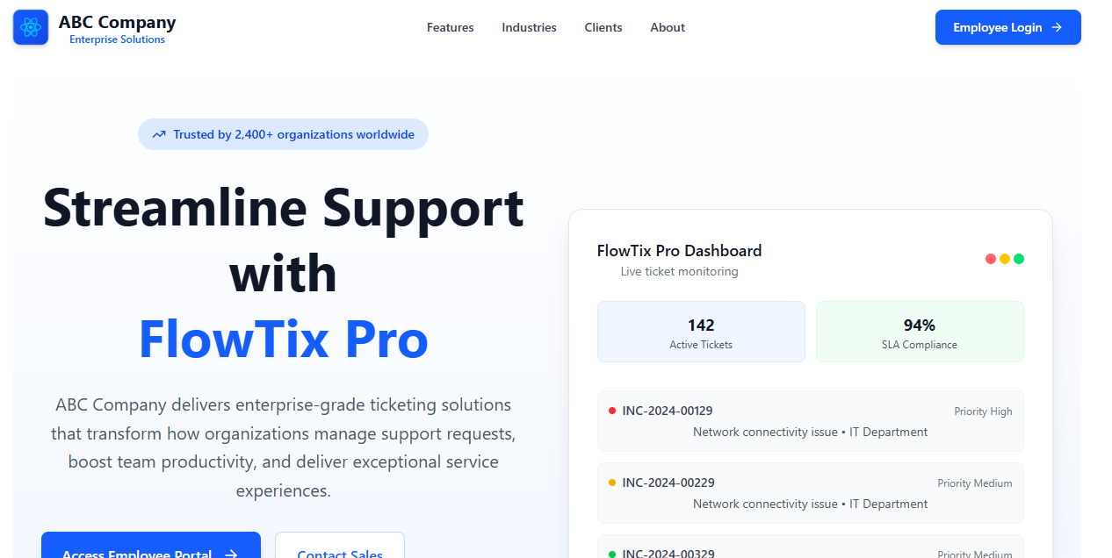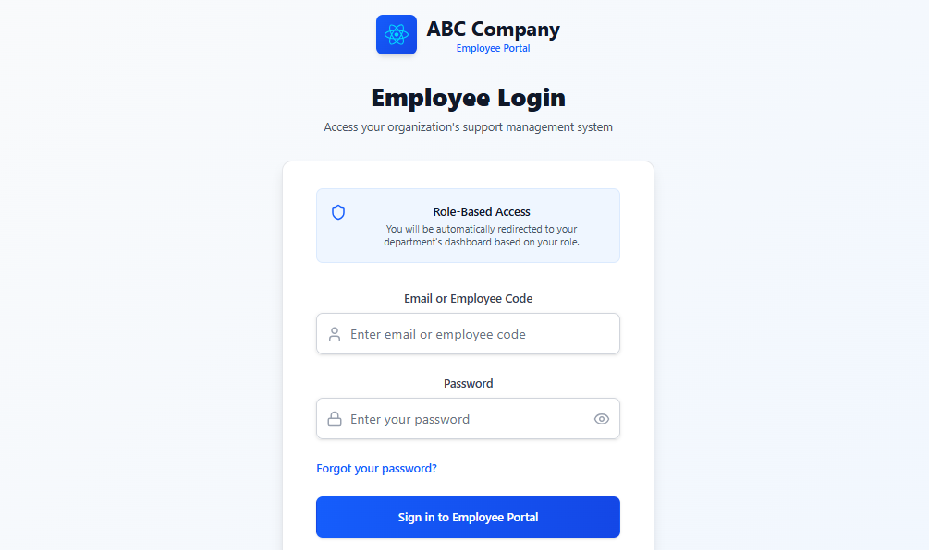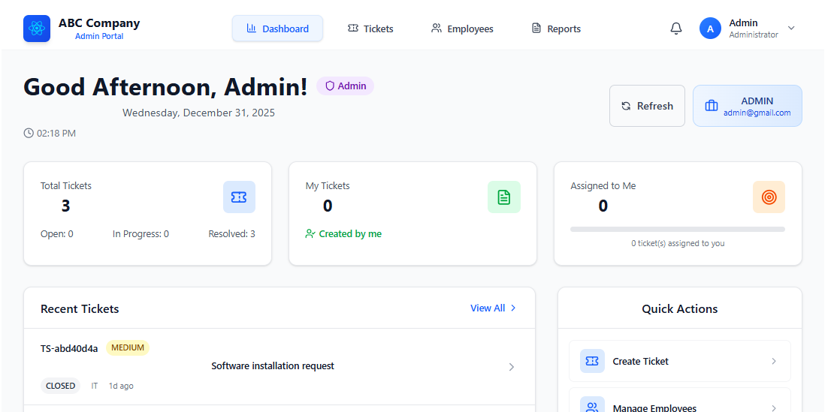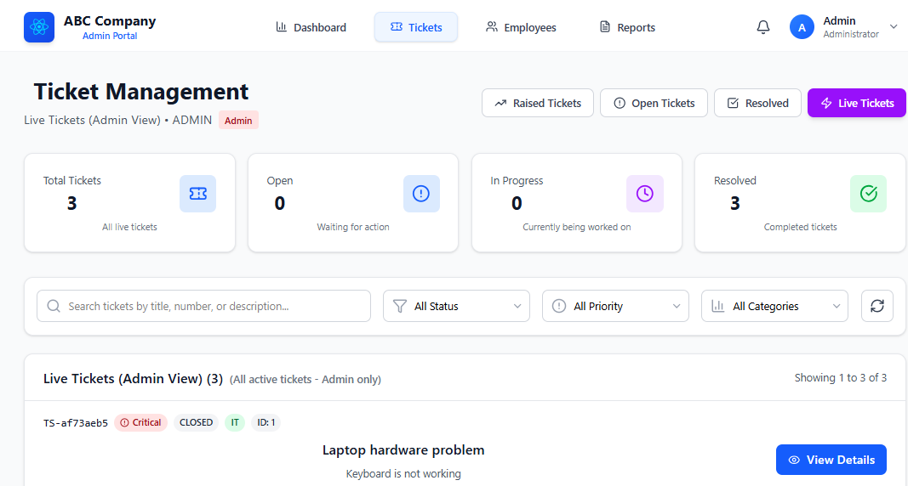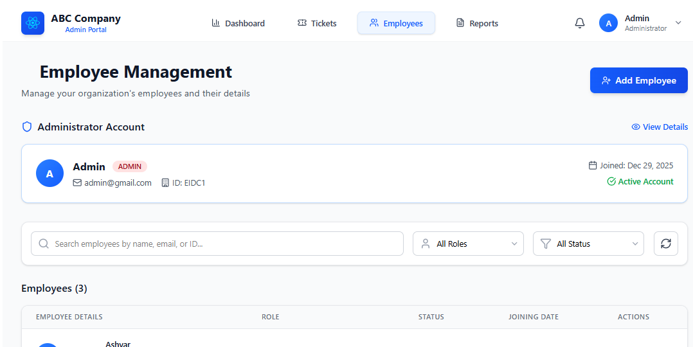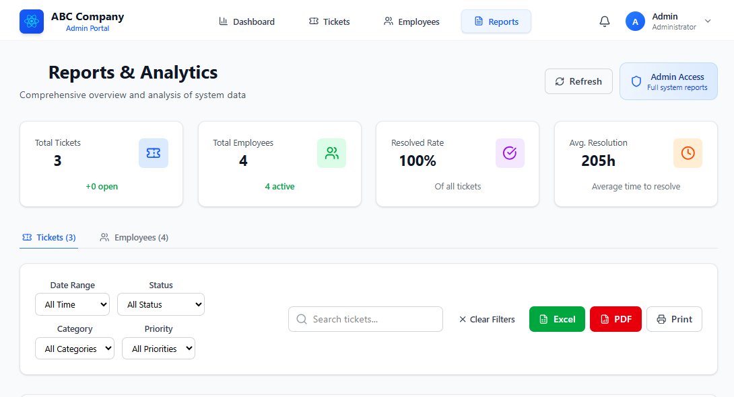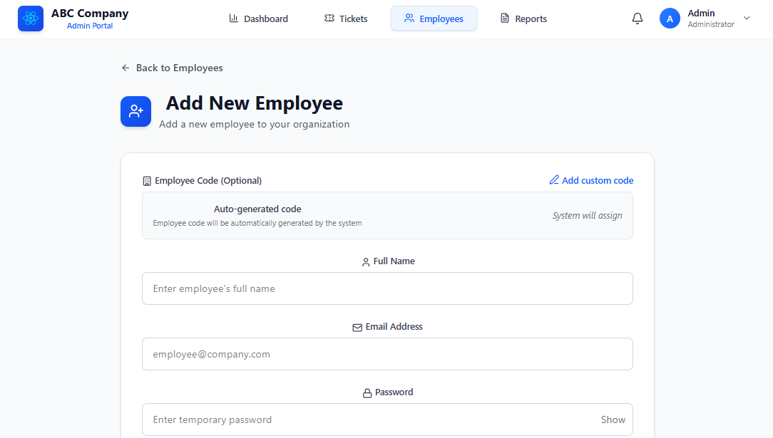

13. FUTURE ENHANCEMENTS
13.1 Mobile Application Development
- Native Mobile Apps: Develop dedicated iOS and Android applications with push notifications and offline capabilities
- Mobile-Specific Features: Camera integration for photo attachments, location-based ticket creation, and mobile-optimized workflows
13.2 Artificial Intelligence Integration
- Smart Ticket Routing: AI algorithms to automatically assign tickets based on employee expertise and workload
- Auto-Categorization: Natural language processing to automatically categorize tickets from descriptions
13.3 Advanced Analytics Dashboard
- Predictive Analytics: Forecast resolution times and predict future ticket volumes for resource planning
- Interactive Reports: Customizable dashboards with drill-down capabilities for performance analysis
13.4 Third-Party Integrations
- Single Sign-On (SSO): Integration with enterprise authentication systems like Azure AD and Okta
- Chat Platform Integration: Connect with Slack and Microsoft Teams for notifications and ticket updates
13.5 Multi-Channel Notifications
- SMS Alerts: Send critical ticket updates via SMS for urgent issues
- WhatsApp/Telegram Integration: Notifications through popular messaging platforms
13.6 Knowledge Base & Self-Service
- Public Knowledge Base: Searchable repository of solutions for common issues
- Community Forum: Peer-to-peer support platform for users to share solutions
13.7 Workflow Automation
- Visual Workflow Builder: Drag-and-drop interface for creating custom ticket workflows without coding
- Automated Escalation Rules: Time-based automatic escalation of unaddressed tickets
13.8 Enhanced Security Features
- Multi-Factor Authentication: Add TOTP or biometric authentication for enhanced security
- Advanced Audit Trails: Comprehensive logging with tamper-evident records for compliance
13.9 Customer Portal Development
- External Client Portal: Allow external customers to submit and track tickets
- SLA Tracking: Visual service level agreement tracking with breach notifications
13.10 Microservices Architecture
- Service Decomposition: Convert monolithic application to microservices for better scalability
- Container Orchestration: Implement Kubernetes deployment for automatic scaling

14. CONCLUSION
The Ticketing Software project successfully delivers a comprehensive, role-based internal support management system that addresses the core requirements of modern organizational issue tracking. Through the implementation of a Spring Boot backend with PostgreSQL database and React.js frontend, the system provides a robust, scalable, and user-friendly platform for managing support requests across multiple departments including IT, HR, Network, and Software Engineering.
The system's architecture demonstrates strong adherence to software engineering principles with clear separation of concerns, modular design, and comprehensive security implementation. The layered approach—with distinct controller, service, and repository layers—ensures maintainability and testability while supporting future enhancements. The integration of real-time notifications via WebSocket technology provides immediate feedback to users, significantly improving communication efficiency compared to traditional email-based systems.
Key achievements of this implementation include the successful establishment of role-based access control with appropriate permissions for each user category, automated notification workflows that keep all stakeholders informed throughout the ticket lifecycle, and a secure authentication system with OTP-based password recovery. The system's ability to differentiate between internal and external comments ensures sensitive discussions remain confidential while maintaining transparent communication with ticket creators.
From a technical perspective, the project showcases effective utilization of modern development frameworks and tools, demonstrating proficiency in full-stack development with Java, Spring Boot, React, and PostgreSQL. The implementation addresses both functional requirements—ticket creation, assignment, tracking, and resolution—and non-functional requirements including security, performance, usability, and maintainability.
The Ticketing Software represents a significant improvement over traditional support management methods, offering structured workflows, automated processes, and comprehensive tracking capabilities. By centralizing support requests and standardizing resolution processes, the system enables organizations to improve response times, enhance accountability, and gain valuable insights through reporting and analytics.
Looking forward, the modular architecture and well-documented codebase provide a solid foundation for future enhancements such as mobile applications, AI-powered features, advanced analytics, and third-party integrations. The system's design accommodates scalability to support growing organizational needs while maintaining performance and reliability.
In summary, this Ticketing Software project delivers a practical, efficient, and secure solution for internal support management that balances sophisticated functionality with intuitive usability. It stands as a testament to effective software engineering practices and provides tangible value through improved operational efficiency, enhanced communication, and structured workflow management within organizational support systems.

15. BIBLIOGRAPHY
- Spring Framework Documentation. (2023). Spring Boot Reference Documentation. Spring.io.
Official documentation for Spring Boot 3.x framework covering configuration, security, data access, and WebSocket implementation.
- React Documentation. (2023). React Official Documentation. Reactjs.org.
Comprehensive guides and API references for React.js 18+ including hooks, component lifecycle, and state management.
- PostgreSQL Global Development Group. (2023). PostgreSQL 15 Documentation. Postgresql.org.
Official documentation covering database administration, SQL syntax, performance optimization, and ACID compliance features.
- Oracle Corporation. (2023). Java Platform, Standard Edition Documentation. Oracle.com.
Official Java 17+ documentation including language specifications, API references, and security guidelines.
- Maven Documentation. (2023). Apache Maven Project Documentation. Maven.apache.org.
Complete reference for Maven build tool including dependency management, project structure, and plugin configuration.
- Tailwind CSS Documentation. (2023). Tailwind CSS Official Documentation. Tailwindcss.com.
Comprehensive guide to utility-first CSS framework including responsive design patterns and component styling.
- OWASP Foundation. (2023). OWASP Web Security Testing Guide. Owasp.org.
Security best practices and testing methodologies for web applications covering authentication, authorization, and data protection.
- Fowler, M. (2018). Patterns of Enterprise Application Architecture. Addison-Wesley.
Foundational text on software architecture patterns including layered architecture, domain models, and data mapping patterns.
- Martin, R. C. (2017). Clean Architecture: A Craftsman's Guide to Software Structure and Design. Prentice Hall.
Principles for creating maintainable, testable software architecture with clear separation of concerns.
- Evans, E. (2003). Domain-Driven Design: Tackling Complexity in the Heart of Software. Addison-Wesley.
Methodology for connecting software implementation to evolving business models and domain logic.
- World Wide Web Consortium (W3C). (2023). Web Content Accessibility Guidelines (WCAG) 2.1. W3.org.
International standards for web accessibility ensuring software usability for people with disabilities.
- Internet Engineering Task Force (IETF). (2011). RFC 6455: The WebSocket Protocol. IETF.org.
Technical specification for WebSocket protocol enabling full-duplex communication channels over a single TCP connection.
- Gamma, E., Helm, R., Johnson, R., & Vlissides, J. (1994). Design Patterns: Elements of Reusable Object-Oriented Software. Addison-Wesley.
Classic reference for software design patterns including observer, repository, and service layer patterns implemented in this project.
- Spring Security Team. (2023). Spring Security Reference Documentation. Docs.spring.io.
Comprehensive guide to implementing authentication, authorization, and security features in Spring applications.
- Java Community Process. (2023). Jakarta Persistence API Specification. Jakarta.ee.
Standard API for object-relational mapping and persistence management in Java applications.
- Axios Documentation. (2023). Promise Based HTTP Client for Browser and Node.js. Axios-http.com.
Documentation for HTTP client library used for API communication between frontend and backend.
- WebSocket API Documentation. (2023). MDN Web Docs. Developer.mozilla.org.
Comprehensive reference for WebSocket API implementation in web browsers.
- Mockito Framework. (2023). Mockito Documentation. Site.mockito.org.
Documentation for mocking framework used in unit testing of service layer components.
- JUnit Team. (2023). JUnit 5 User Guide. JUnit.org.
Testing framework documentation for writing and running repeatable tests in Java.
- ISO/IEC 25010. (2011). Systems and software engineering — Systems and software Quality Requirements and Evaluation (SQuaRE) — System and software quality models. International Organization for Standardization.
International standard for software quality characteristics including functional suitability, reliability, and security.
Online Resources & Tools
- Stack Overflow Developer Survey. (2023). Most Popular Technologies. Stackoverflow.com.
Industry survey data informing technology selection and implementation trends.
- GitHub Documentation. (2023). GitHub Guides. Docs.github.com.
Version control best practices and collaborative development workflows.
- Postman API Platform. (2023). API Development and Testing Documentation. Postman.com.
Tools and methodologies for API testing, documentation, and monitoring.
- VS Code Documentation. (2023). Visual Studio Code User Guide. Code.visualstudio.com.
Integrated development environment setup, extensions, and productivity features.
- Spring Tool Suite Documentation. (2023). STS 4 User Guide. Spring.io/tools.
IDE-specific features for Spring application development and debugging.
Academic References
- Sommerville, I. (2016). Software Engineering (10th ed.). Pearson Education.
Comprehensive textbook covering software development life cycle, requirements engineering, and system testing.
- Pressman, R. S., & Maxim, B. R. (2020). Software Engineering: A Practitioner's Approach (9th ed.). McGraw-Hill Education.
Methodologies for software project management, quality assurance, and maintenance.
- IEEE Computer Society. (2014). IEEE Standard for Software Quality Assurance Processes. IEEE Std 730-2014.
Standards and guidelines for software quality assurance and process improvement.
This bibliography includes both technical references for implementation technologies and theoretical foundations for software engineering practices, providing comprehensive support for the design, development, and documentation of the Ticketing Software system.

